Nurse Residency Program
It is never too early to start planning for your first job as a professional nurse! Cheyenne Regional Medical Center has a Nurse Residency Program that is designed to ease your transition from the world of academia to the professional nurse role. We would love a chance to meet with you and discuss the possibilities for your future at Cheyenne Regional Medical Center.

If you are interested in learning more about our program or would like to meet with the Nurse Residency Program Director, please call Lyndsey Smith at 307-996-4731 or email lyndsey.smith@crmcwy.org. You can also reference our website at https://www.cheyenneregional.org/careers/nurse-residency-program/
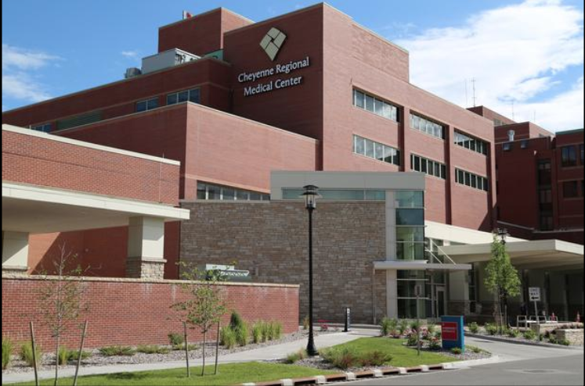
Nurse Residency Program Frequently Asked Questions
- Can I apply to the Nurse Residency Program if I haven’t graduated from nursing school?
- Please plan to apply to the Nurse Residency Program about 2-3 months prior to your graduation date.

- What shifts are Nurse Residents assigned to?
- Night shift is common. Please mentally prepare yourself to stay on nights for a while. This is where Nurse Residents struggle the most. Many times, managers will not be able to move you to days for extended periods of time (this is unit specific depending on needs).

- How many hours a week will I work?
- Full-Time (36 hours a week) plus Nurse Residency class time *1872 hours commitment to your unit of hire, following successful completion of unit orientation*
- After you are off unit orientation you may be given the option to work extra shifts

- How many Nurse Residents are typically hired?
- This highly depends on the number of open positions and the quality of the interviews.

- Is the Nurse Residency a paid program?
- Yes, you will be paid an hourly wage both for attending Nurse Residency classes and for your unit-based work/training.

- How long is the application open?
- The application cycle open for a 2-week period of time, 3 times a year. Application cycles are in March (May graduates), July (August graduates), and October (December graduates).
- You can apply at https://www.cheyenneregional.org/careers/nurse-residency-program/

- How long after applying will I know if I have an interview?
- After you apply, an email will be sent to you to let you know that your application has been received and further information regarding possible interview dates. If you are not selected for an interview, you will be notified by email.

- What will my starting wage be?
- You will receive an RN wage. Each potential employee receives an individualized wage analysis.
- This will be discussed after an interview has occurred and an offer is to be extended.
- Please contact Human Resources for this information at 307-633-7752.

- Is there a Nurse Residency Agreement for the Nurse Residency Program?
  - There is an incentive-based agreement.
  - We require you work on your unit of hire in a full-time status for a minimum of 1872hrs, after you have successfully completed your orientation period.
  - We require a BSN within 4 years of hire.
  - 100% Class attendance is required.
Nurse Resident Placement

*Please note that specialty units have limited positions available- (ARU, ED, ICU, WCS)

- Acute Care Units
Typical Orientation Length 10 – 16 weeks
- Surgical Ortho-Neuro- Typical patient diagnosis/treatment may include: Abdominal surgery, bariatric surgery, other general surgical procedures, joint replacement/spinal surgical patients, epilepsy, CVA/TIA, and medical overflow patients
- Telemetry- Typical patient diagnosis may include: Pre and Post-op open-heart surgery patients, CHF, cardiac monitoring, treatment of irregular heart rhythms, Pre and Post-cardiac catheterization lab patients, vascular patients, and medical overflow patients
- Medical- Typical patient diagnosis may include: COVID- 19, COPD, diabetic patients with complications, CHF, GI bleed, renal failure etc.
- Medical/Oncology- Typical patient diagnosis/treatment may include: Chemotherapy, patients with a history of cancer, patients requiring inpatient chemotherapy, and medical overflow patients

- Critical Care Areas
Typical Orientation Length 16-24 weeks
- ED- Treats all age categories and conditions
- ICU- Treats all critically ill adult patients (and occasionally teenaged patients)

- Women and Children’s Services
Typical Orientation 3 weeks Mother-Baby/3 weeks Secondary Nurse for Peds
  - All Nurse Residents who begin working in the Women and Children’s Department will begin working on the Mother-Baby or Pediatric unit initially. As you advance in your training, your manager will begin planning with you to talk about training you to additional areas within the department.

- Rehabilitation Unit
Typical Orientation Length 10 – 16 weeks
  - Acute Rehab Unit- Typical patient seen: Medically stable patients who may be recovering from surgery or working on gaining mobility and independence prior to discharge home or to another care facility

***Internal Candidates- Please note that if you are hired to transition from a CNA or LPN position to a Nurse Resident Position your orientation length may vary.

