UKG How-to Guide – Qualifying Life Events

Navigation in UKG: Menu > Myself > Benefits > Manage My Benefits
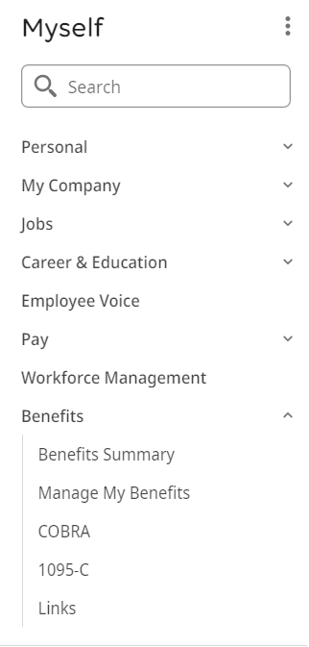
From the Manage My Benefits page, click on Update My Benefits or Update your current benefits to make benefit election changes.
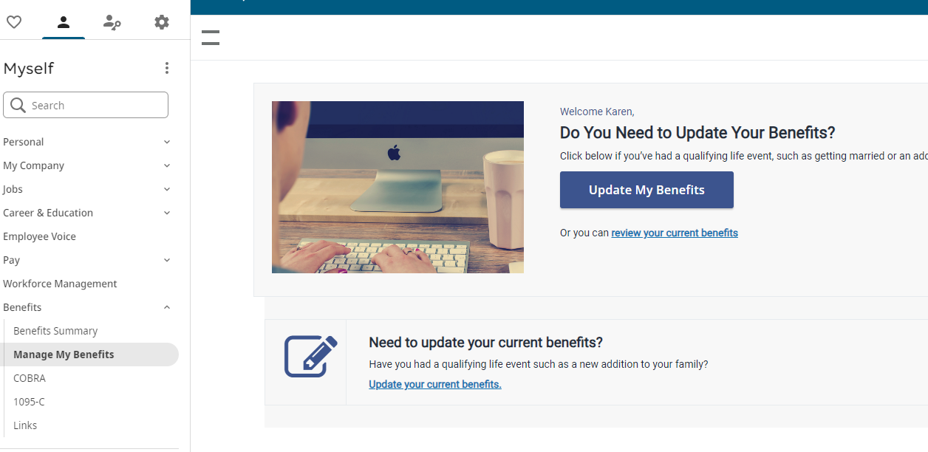
Step 1: Report Life Event
Select the type of Life Event from the drop-down list to indicate the reason you are making the change. System will ask for Event Date or effective date of change. Then, select Continue.

Step 2: Review Profile
From the Manage your profile page, verify your personal information is accurate. Once you have verified or edited personal information select Next: Review My Family.

Step 3: Verify Dependents
From the Manage Your Family Members information page, you can view, edit, or remove dependents. You will need to confirm that all information for your dependents is listed correctly (including social security numbers and date of birth.) If you add a new family member, the family member won’t be added to your benefits automatically. You will still need to add the family member to any applicable benefits. Dependents must be listed on this page to be enrolled in coverage. Review current family members information to ensure it is accurate. Then select, Next: Shop for Benefits
- Update information by completing one of the following using the Add/Change contact page.
  - Select the Edit to update existing dependent information.
  - To add a beneficiary or dependent, select Add.
- Select Save.

Step 3: Elect Your Benefits
- Select View or Change for each plan option to make changes to your current elections.
- Select the dependents to be enrolled in each plan option.
- Select Update Cart to add plan option or Decline Coverage to decline coverage.
- Once all plan options have been selected or waived, Select Review and Confirm
You must select or decline each plan. For example, for the Flexible Spending Account plan type, you may select or decline dependent care or health care.
Evidence of insurability (EOI) may be required for life insurance plans. A message appears stating that evidence of insurability is required for amounts surpassing the amount the company has configured as the guaranteed issue amount for a particular plan. The maximum benefit amount that can be elected appears.
Based on the valid dependent relationships configured by your company for the plan, only those dependents who match the relationship configured for the plan will appear for enrollment. For example, while you may have "spouse", "child", and "brother" configured as dependents in your contacts, the plan you are enrolling in may only have spouse and child configured as valid dependent relationships for plan enrollment.

Step 4: Review and Submit Elections
Review the election information on the Confirm your Benefit Elections page. This page contains personal information as well as the selected and declined benefits.
- Review the selected and declined benefit type and plan details including covered family members, plan beneficiaries, and cost information.
- Return to the applicable page to complete changes, as needed.
- Select Checkout, to complete the enrollment process.
- Select Send my Email to send confirmation statement and select email address.
Step 5: Documentation Request
Supporting documentation will need to be uploaded in UKG to verify qualifying life event.
For additional questions, you can reach out to the Benefits Team at 307-633-7700 or benefits@crmcwy.org.

