 *Bruce D. Smith, M.D - John E. Winter, M.D. - Michael J. Shannon, M.D.*

*Bret R. Winter, M.D. - Gary I. Molk, D.O. – Daniel Kisicki, M.D.*

*Lindsay Tully, PA-C - Kelli A. Chambers, PA-C*

Date: __________________ **Patient’s History of Present Illness**

Patient Name: ___________________________________________ Date Of Birth: ______________________

R L L R

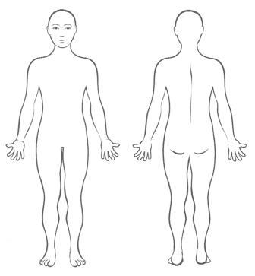

1. Please tell us **where** your pain is located. (Shade the area on the diagram)

2. Does your pain **radiate** or **move** to other locations? (Indicate with arrow)

3. On a scale of 0-10, please **rate** your pain.

0 = no pain 10 = Pain that would send you to the ER

0 1 2 3 4 5 6 7 8 9 10

At best: _______ At worst: _______

4. What makes your pain worse? ______________________________________________________________

5. What makes your pain better? _______________________________________________________________

6. Do you have sensations of **POPPING**, **LOCKING**, or **GRINDING**? _______________________________

If yes, is it painful when these things occur? ________________________________________________

7. Do you have any **WEAKNESS** or sensations of it **GIVING WAY**? ________________________________

8. Please choose from the following list of terms to **describe the pain**

Sharp Dull Aching Stinging

Rubbing Burning Pulling Pressure

Tearing Cramping Stabbing Stretching

Other: _________________________________________________

9. Do you have any **numbness** or **tingling** near the painful area? ____________________________________

10. Does the pain wake you from sleep at night? __________________________________________________

11. Do you need a note for work or School? **Yes No**

12. Do you need a medication refill? **Yes No** I am taking: _______________________________

13. Preferred Pharmacy ____________________________________