Nurse Residency Program
It is never too early to start planning for your first job as a professional nurse! Cheyenne Regional Medical Center has a Nurse Residency Program that is designed to ease your transition from the world of academia to the professional nurse role. We would love a chance to meet with you and discuss the possibilities for your future at Cheyenne Regional Medical Center.

If you are interested in learning more about our program, or would like to meet with the Nurse Residency Program Director, please call Tess Taylor at 307-996-4743 or email tess.taylor@crmcwy.org. You can also reference our website at https://www.cheyenneregional.org/careers/nurse-residency-program/
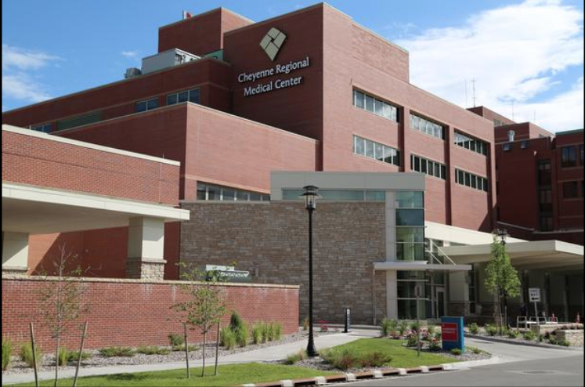
Nurse Residency Program Frequently Asked Questions

- Can I apply to the Nurse Residency Program if I haven’t graduated from nursing school?
- You may apply and interview promptly before you have graduated nursing school, however, you must pass your nursing boards and have your Wyoming license by the time you start as a new employee. (Example- I graduate in May. When should I apply? Look to apply a few months before your graduate in March or April).

- What shifts are Nurse Residents are assigned to?
- This is dependent on the unit’s staffing needs and currently there are some night and some day shift Nurse Residents. Night shift is common for the first year.

- How many hours a week will I work?
- Full-Time (36 hours a week) plus class time *1-year commitment to full-time
- After you are off unit orientation you may be given the option to work extra shifts

- How many Nurse Residents are typically hired?
- This highly depends on the number of open positions and the quality of the interviews.

- Is the Nurse Residency a paid program?
- Yes, you will be paid an hourly wage both for attending Nurse Residency classes and for your unit-based training.

- How long is the application open?
- The application is typically open for about 1 month
- Check at https://www.cheyenneregional.org/careers/nurse-residency-program/ to see if the application is open

- How long after applying will I know if I have an interview?
- After you apply an email will be sent to you to let you know that your application has been received and further information regarding interviews and start dates. If you are not selected for an interview you will be notified by email.

- What will my starting wage be?
- Please contact Human Resources for this information at 307-633-7752
- You will receive an RN wage.

- Is there a Nurse Residency Agreement for the Nurse Residency Program?
- This is currently under revision and shifting to an incentive-based agreement
  - We require you work on your unit of hire full-time for 1 year
  - We require a BSN within 4 years of hire

Nurse Resident Placement

*Please note that specialty units have limited positions available- (ED, WCS, ICU, ARU)

- Acute Care Units Typical Orientation Length 10 – 16 weeks
- Ortho-Neuro- Typical patient diagnosis/treatment may include : Joint replacement/spinal surgical patients, Epilepsy, CVA/TIA, and medical overflow
- Surgical- Typical patient diagnosis/treatment may include: Abdominal surgery, bariatric surgery, other general surgical procedures, and medical overflow
- Oncology- Typical patient diagnosis/treatment may include: Chemo therapy, patients with a history of cancer, and medical overflow
- Medical- Typical patient diagnosis may include: COPD, Diabetic Patients with complications, CHF, GI bleed, renal failure etc.

- Rehabilitation Unit (Rarely Hires) Typical Orientation Length 10 – 16 weeks
- Acute Rehab Unit- Typical patient seen: Medically stable patients who may be recovering from surgery or working on gaining mobility and independence

- Critical Care Areas Typical Orientation Length 16-26 weeks
- Telemetry- Typical patient diagnosis may include: Pre and Post op Open Heart patients, CHF, Heart monitoring, treatment of irregular heart rhythms, Pre and Post cardiac cath lab patients
- ED- Treats all age categories and conditions
- ICU- Treats all critically ill adult patients (and occasionally teenaged patients)

- Women and Children’s Services Typical Orientation 3 weeks Mother-Baby/ 3 weeks Secondary Nurse for Peds
  - All Nurse Residents who begin working in the Women and Children’s Department will begin working on the Mother-Baby or Pediatric unit initially. As you advance in your training your manager will begin planning with you to talk about training you to additional areas within the department.

***Internal Candidates- Please note that if you are hired to transition from a CNA or LPN position to a Nurse Resident Position your orientation length may vary.

