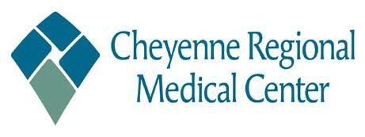
Employee CareFund Program Application
Name
Date Employee ID/Badge #

Address City State Zip Code

Department Current Position Hire Date

Job Status: FT _________ PT_________
PRN ___________ (PRN worked minimum hours of 250 worked over last nine (9) months)

Reason for Employee CareFund Need:

Supporting Documentation Attached:
__________________________________________________ _________________________
(Supporting Documentation (for everything but groceries and gasoline) must be attached for Employee CareFund Program Application to be considered)

I have read and understand the policy for the Employee CareFund Program and certify I meet all eligibility requirements.
__I certify I have completed nine (9) consecutive months of service with Cheyenne Regional.
I certify that all information contained in this application is true, correct and falsification of information may result in denial and/or corrective action.
I certify I have had no corrective actions within the last 12 months.
I understand that Cheyenne Regional reserves the right to amend or terminate the offering of the Employee CareFund program, at any time.
__I understand the maximum benefit paid is $3,000 within three (3) years from the date of application.
__I understand that funds from the Employee CareFund Program pays approved expenses directly to the creditors (except for groceries or gasoline).
I understand that this is not a contract of employment, and that all employment with Cheyenne Regional is voluntary and at-will, meaning that I or Cheyenne Regional have the right to terminate the employment relationship at any time, for any reason or no reason, and that this agreement does not alter that at-will employment relationship.

Signed

Date

APPROVAL / DENIAL:

Has Employee had any corrective actions in the last 12 months? Y / N

Employee CareFund Program Committee Date

Approved:

Denied & Reason

