- There are multiple ways to access the ADP site for your W2 and 1095-C forms.
  - Go to the intranet site, click on Staff Resources->HCM->View your W2/1095-C.
  - The same link will also be on the internet site under Staff/Employees->HCM ADP W2/1095-C
  - Https://my.adp.com in any browser.
- You will see the Log in to ADP login screen
- To reset your password, click on the “FORGOT YOUR ID/PASSWORD” link. 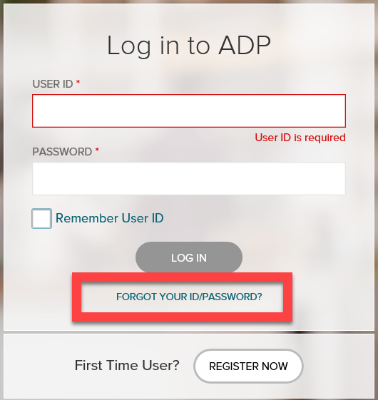
- The Forgot UserID/Password screen opens and asks you for your First Name, Last Name, and one of the fields: email address OR mobile phone number that you registered with. Click Next.

- Your User ID screen opens and indicates your user id. Note your userid for future reference. If the user id is all that is needed, you can click on the Sign In button to log into ADP.
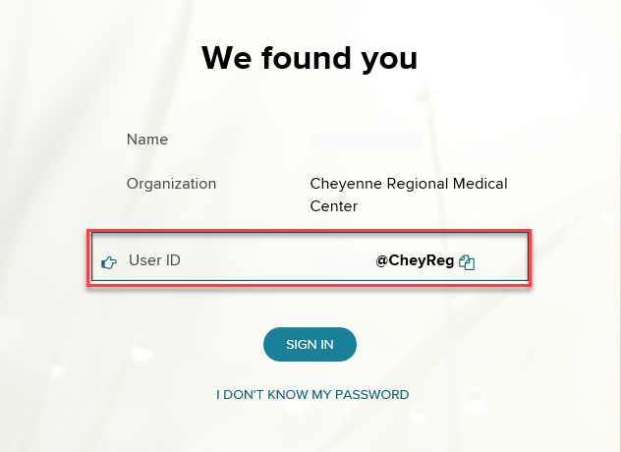
- If you need to reset your password, click on the button “I DON’T KNOW MY PASSWORD”. NOTE: You will receive a notification (email/mobile text) indicating that an attempt to retrieve your user id has been requested. The email will be sent from SecurityServices_NoReply@adp.com if email was used.
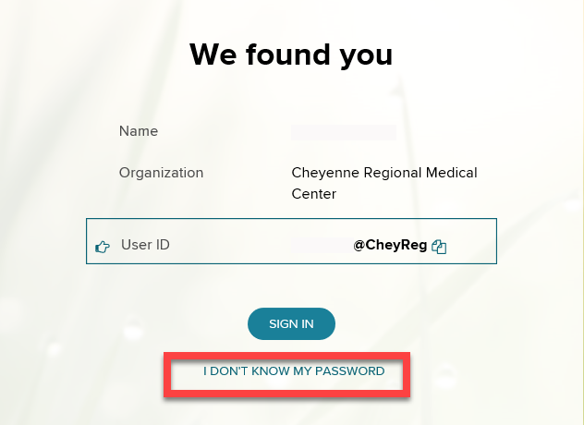

- Your Security code window will open and provide options of which method to receive the ADP code (Text or email). Select the method of choice and click Send Code.
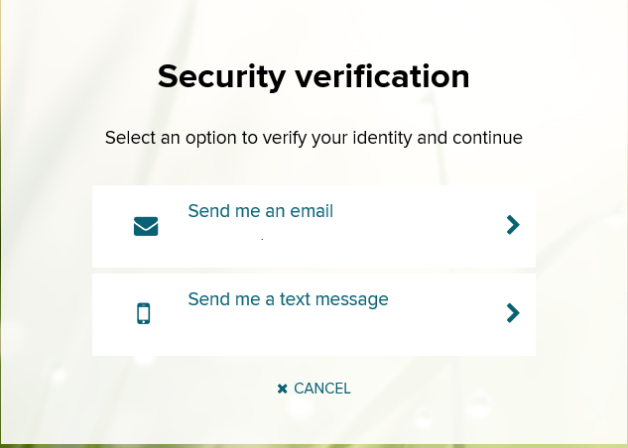

- Based upon the method, you will be prompted to enter in the security code and you will receive the ADP code from an email or a text. Enter in the security code provided, as you will have a time limit to enter in that information and click Submit.
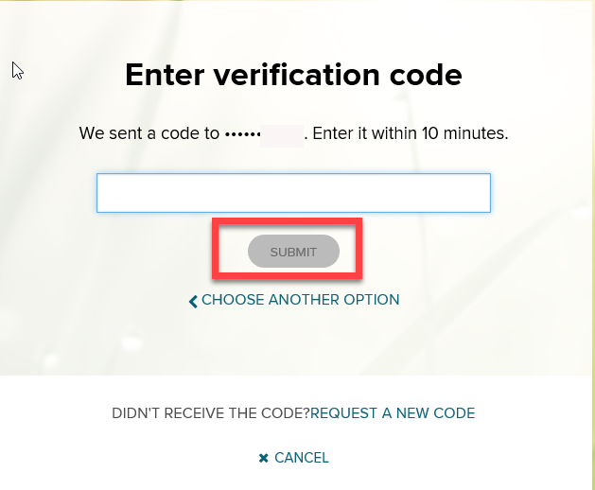
- The Reset password window opens prompting you to enter in a new password and confirm your new password. Note: There is a password criteria and you can click on the information symbol to get more details on what is needed in the password.

- Click Submit.
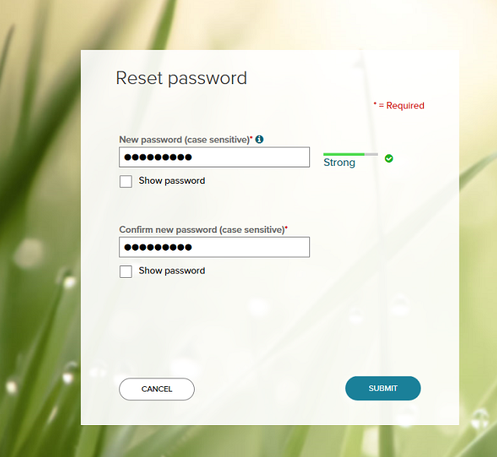

- If the password was successful you will have the following window to confirm. Click Close.

- The ADP Login screen appears for you to login with your User ID and the reset password you just entered.

- Once logged in, you can review your settings within the portal by clicking on the down arrow under your name in the right-hand side and select Settings to change the following:

- Contact Preferences
- Email Notification
- Security Questions
- Accessibility
- Password

