- There are 3 ways to view your W2.
  - Go to the intranet site, click on Staff Resources->HCM->View Your W2/1095-C.
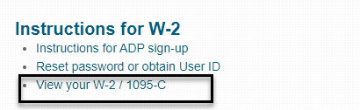
  - The Internet site under Staff/Employees->HCM ADP W2/1095-C
  - Or you can type in a browser https://my.adp.com

- Click on the “Register Now” button as employees will need to establish an ADP user id and password.
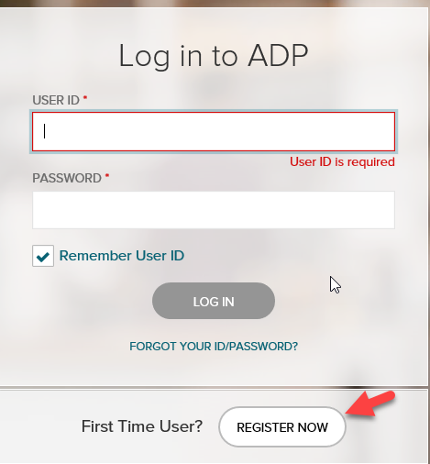

- When Create your account window opens, select I HAVE A REGISTRATION CODE.
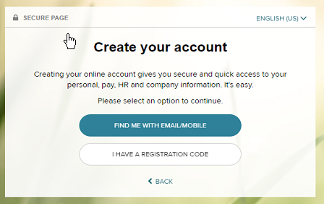

- The registration code window opens, enter CheyReg-W2 as the registration code and click Next.
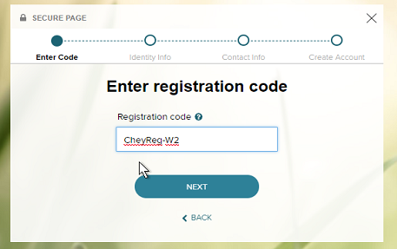

- The Identify yourself screen will open. You must enter information in the fields that are highlighted in yellow. Leave all other fields as the default.
- First Name
- Last Name
- Service name and document –W2 services is defaulted
Year of W-2: 2019 is defaulted
- Control number -Employee ID: (use your 5 digit badge number)
- Control number – Company code: R3C
- Employee’s Zip Code
- Employee’s SSA number – using no dashes, enter in your 9-digit SSN
- Click Next.
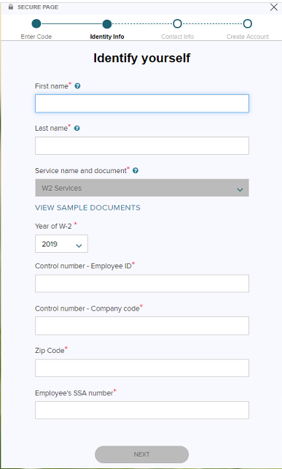
- The Help us Verify your identity screen appears.
Before proceeding please review the following:
- You will be asked a few questions to make sure that you are really you.
NOTE: These questions are generated from public records and other data sources. These questions are not used for any purpose other than to verify your identity and not shared with your organization.

- Click Continue to proceed with the questions until all questions are answered.
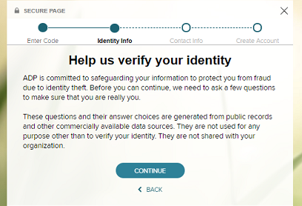

- Once you have answered all the identifying questions, you will be prompted to provide how to contact you when recovering your account login information. You will need to enter the required information and click Continue.
  - Email (work, personal)
  - Phone (mobile, other) that includes area code
NOTE: It will prompt you to verify the acceptance of texting to the number entered
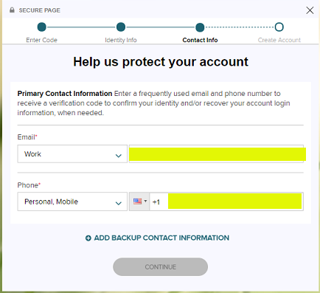

- The next window to appear is to create the account login information.
  - You will be shown your User ID along with your account being assigned to Cheyenne Regional Medical Center.
  - You will be required to enter in a password for the User ID that will end in @CheyReg.
  - You will need to check the Accept Terms and Conditions and then click CREATE YOUR ACCOUNT.
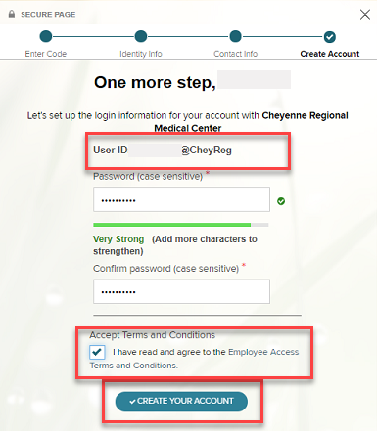

- You will be asked to supply security questions and answers to protect your account and used to verify your identity in the case you forget your user ID and/or password. When done answering all 3 of your questions that you have selected, click Continue.

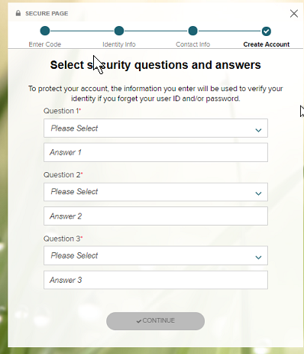
- You will now see the window indicating that your registration is complete!
Note: You will be provided again with what your UserID is and that you will have 24 hours to activate the method you chose (email and/or text) based upon the information given. Please note this information for future reference.
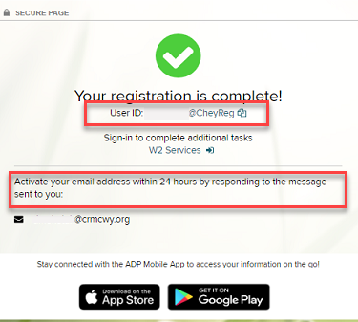
- If you opted for text notification, follow the text instructions on your mobile phone.
- You can click on the W2 Services button to log into the ADP portal with the recently created userid and password. You log in to the portal and the below landing page will appear or you can type in the address of http://www.myadp.com.
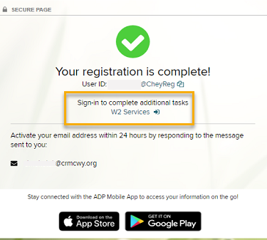
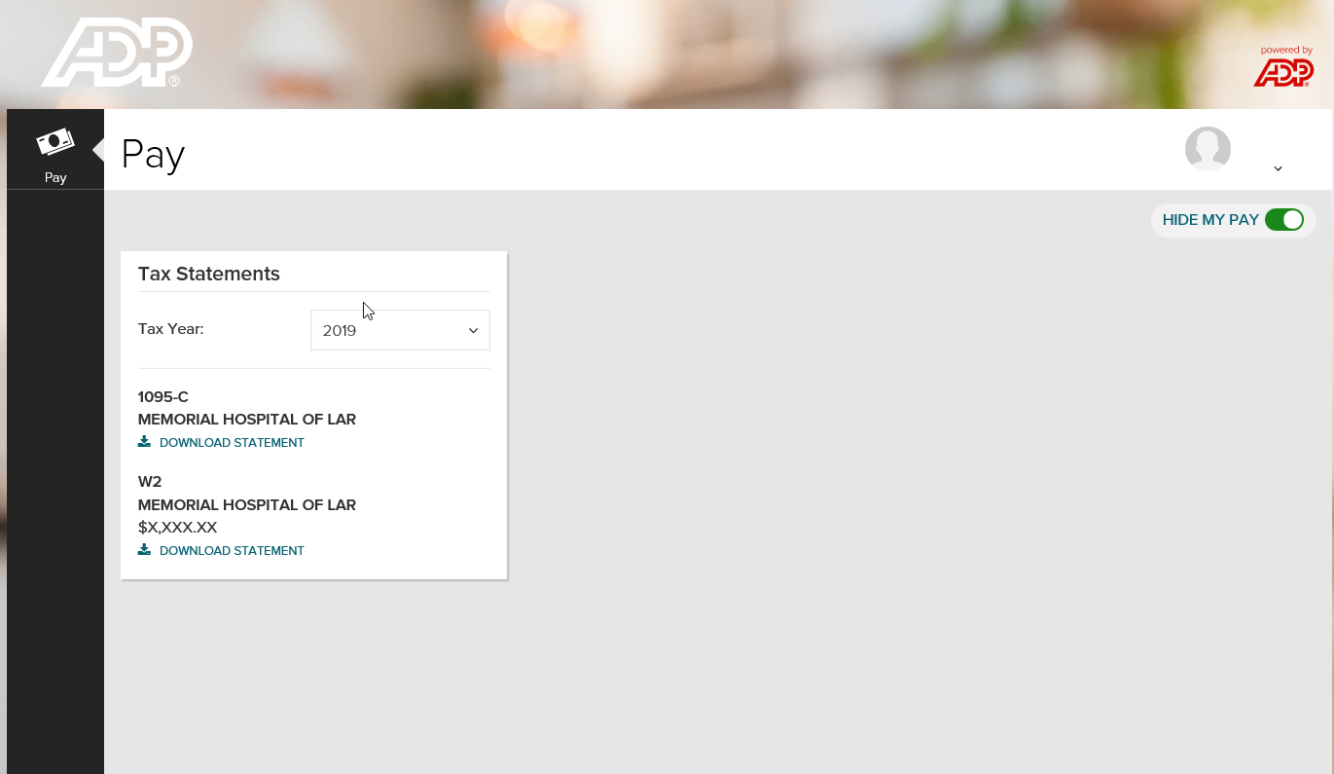
- Activate your email address – during registration if you provided an email address look for the email from ADP. Click the link in the email you receive from SecurityService_NoReply@ADP.com to complete the activation (see below).
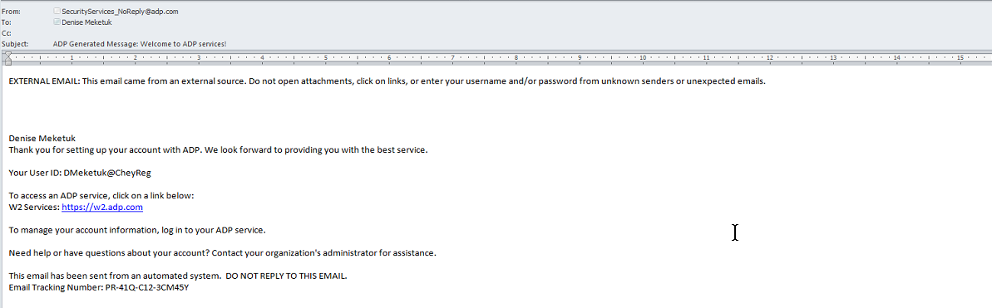
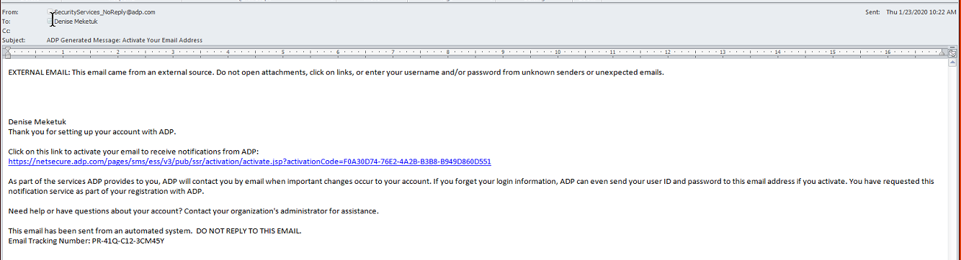

- During Registration if you provided a mobile phone number look out for a text message from ADP and reply with the code indicated.

- Additional information:
- To change your account settings when hovering over or clicking on your profile in the top right corner of the page:
