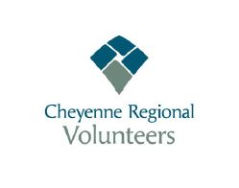Cheyenne Regional Medical Center
Volunteer Organization
GRANT COMMITTEE GUIDELINES

Grant must impact patients or customers of CRMC
No Grant that would cover salaries, wage and/or contract employee will be considered.
No Grant asking for travel costs for whatever purpose will be considered.
No education conferences, seminars or training courses will be considered.
The above guidelines apply to everything outside of the Volunteer organization.
Grant Applications must be of a tangible nature.

Julie Long
March 1, 2018

Subject to Volunteer Board Approval.

