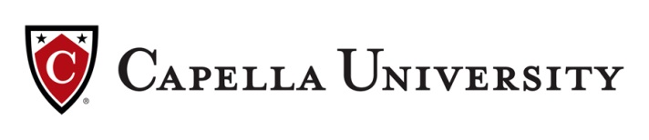
Invested in Your Success
A positive patient experience is not possible without a positive employee experience. That’s why Cheyenne Regional Medical Center has chosen to invest in your personal development by partnering with Capella University to help employees like you continue to pursue excellence through reaching your educational goals.

Wrap your BSN degree around your demanding work schedule and earn the same BSN as a traditional program through Capella University’s revolutionary FlexPath option.

Why earn your RN-to-BSN with FlexPath?
- 50% your first 12-week session
- Additional 10% off tuition discount*
- Move quickly through subjects you know – saving time and money.
- Receive a flat-tuition rate no matter how many courses you complete each 12 weeks.
- Set your own pace to achieve skills and credentials needed to advance.

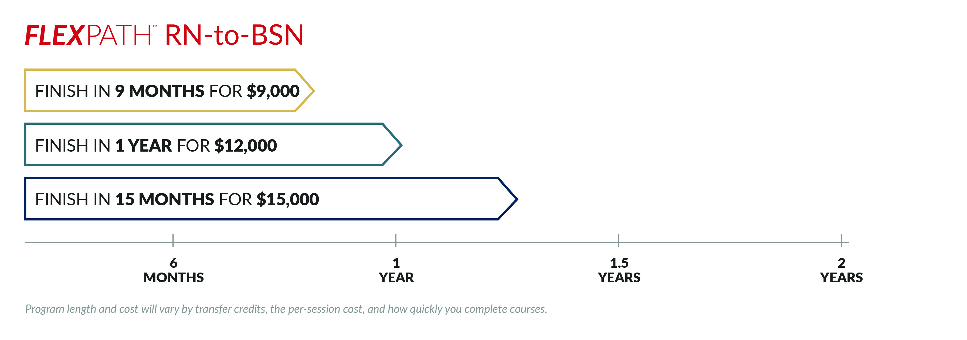

If FlexPath isn’t a fit for you, apply instead for a $4,000 grant plus 10% tuition discount for any Capella degree (excluding FlexPath and certificate programs) that can also be used towards a structured RN-to-BSN option or any of the 53 degree offerings when you enroll between now and December 2018.

Take up to four FREE CE Credits through August 2018
Visit Capella.edu/ CRMCWY for details and course topics

For all partnership benefits visit Capella.edu/CRMCWY

Important information about the educational debt, earnings, and completion rates of students who attended these programs.
*Eligibility rules apply, and discounts may not be available for select programs. Connect with us at Capella.edu/CRMCWY to learn more.

