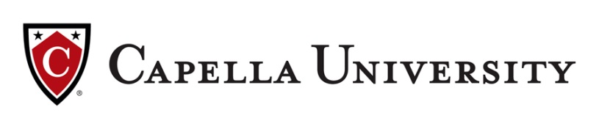
Wrap your degree around your demanding work schedule and earn the same degree as a traditional online program through Capella University’s revolutionary FlexPath option.

Why earn your degree with FlexPath?
- 50% your first 12-week session
- Additional 10% off tuition discount*
- Move quickly through subjects you know – saving time and money.
- Receive a flat-tuition rate no matter how many courses you complete each 12 weeks.
- Set your own pace to achieve skills and credentials needed to advance.

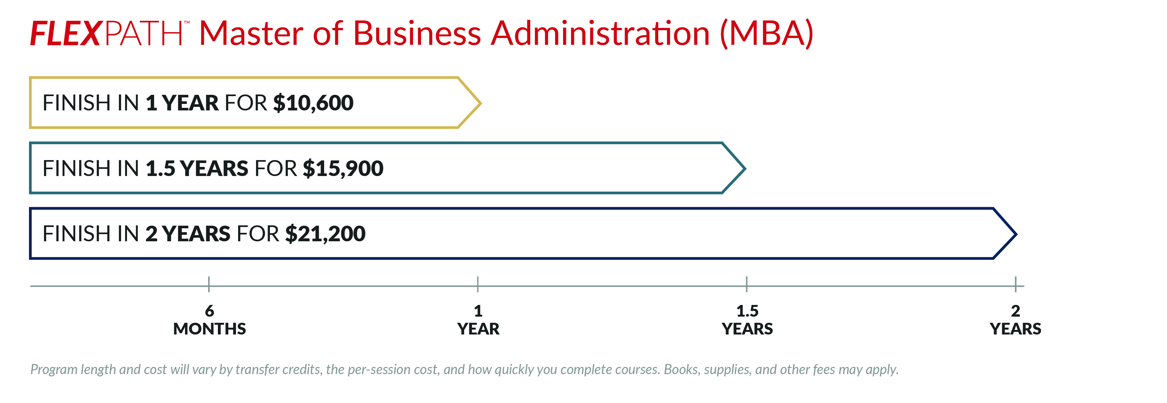
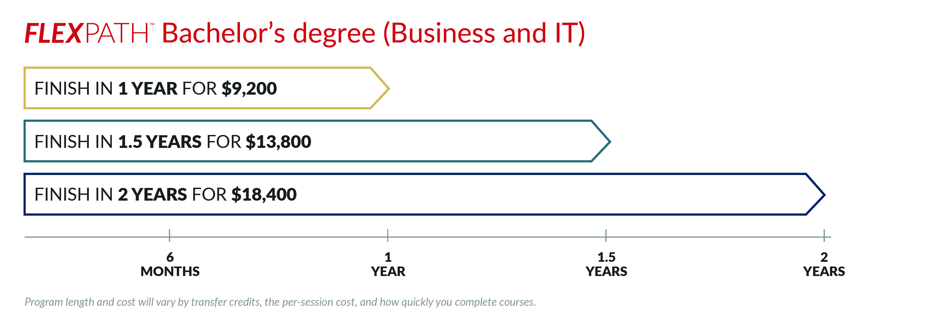

If FlexPath isn’t a fit for you, apply instead for a $4,000 grant plus 10% tuition discount for any Capella degree (excluding FlexPath and certificate programs) that can also be used towards a structured degree option or any of the 53 degree offerings when you enroll between now and December 2018.

On-Demand Professional Development Webinars and FREE CE courses
Visit Capella.edu/CRMCWY partner page for details

For all partnership benefits visit Capella.edu/CRMCWY

Important information about the educational debt, earnings, and completion rates of students who attended these programs.
*Eligibility rules apply, and discounts may not be available for select programs. Connect with us at Capella.edu/CRMCWY to learn more.

