**Rheumatology**



2301 House Ave., Suite 201 • Cheyenne, WY 82001 • (307) 638-7757 • cheyenneregional.org

Date:

**Name:**

**Date of Birth:**

**Appointment Scheduled:**

To assist us in providing the best care possible, we ask for your assistance in the following areas:

1. Please ask your referring provider to send any records, labs, radiology reports, etc. that may pertain to their referral.
2. Please show up 15 minutes early for your appointment so our front office staff will be able to check you in in a timely manner. **Patients that are more than 10 minutes late may be rescheduled to a later time or date.**
3. Please bring a list of your current medications, prescribed and over the counter.

Please bring your **Insurance Card**, **Copayment** and a **Photo ID.**

If you do not have Medical Insurance or CRMC Charity Care your **NEW PATIENT VISIT DEPOSIT IS $180.00** and your **FOLLOW UP VISIT DEPOSIT IS $120.00.** This is required at the time of service and is not the total cost of your appointment.

We look forward to seeing you soon. If you have any questions or need to reschedule your appointment, **please call the office at 307-638-7757.**

Thank you,

The Medical Specialty Clinic Staff

**Medical Specialty Clinic: Rheumatology   
  
Patient Name: _______________________ Date of Birth: ____________ Today’s Date: __________**

|  |  |  |
| --- | --- | --- |
| **Current Medication** | **Dosage** | **Frequency** |
|  |  |  |
|  |  |  |
|  |  |  |
|  |  |  |
|  |  |  |
|  |  |  |
|  |  |  |
|  |  |  |
|  |  |  |
|  |  |  |
|  |  |  |
|  |  |  |

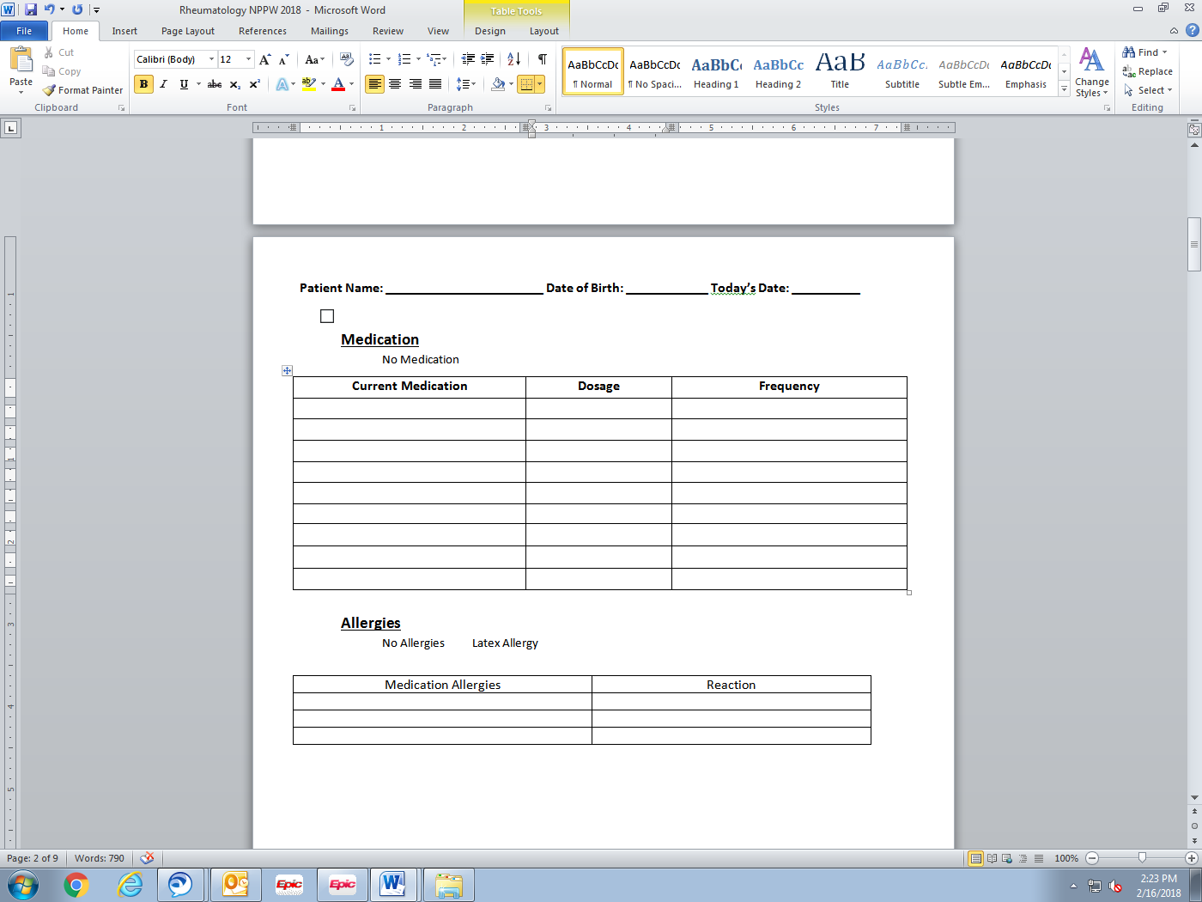**Medication** No Medication **Allergies** No Allergies Latex Allergy

|  |  |
| --- | --- |
| Medication / Food / Any Allergies | Reaction |
|  |  |
|  |  |
|  |  |
|  |  |
|  |  |
|  |  |
|  |  |
|  |  |
|  |  |
|  |  |
|  |  |

**Medical History** (Check All That Apply)

* Alzheimer’s Disease
* Cancer (Type: _____________)
* Stomach Ulcers
* Depression
* Heart Attack (Year:___________)
* High Cholesterol
* Polio
* Kidney Disease
* Lupus
* Rheumatoid Arthritis
* Carpal Tunnel
* Obesity
* Tuberculosis
* COPD
* Genitourinary Disease   
   (Type: ________________)
* Stroke
* HIV (AIDS)
* Peripheral Vascular Disease
* Asthma
* Blood Disease
* Heart Disease
* Rheumatic Fever
* Fracture Spine
* Spinal Cord Injury
* Thyroid Disorder
* Headache, Migraine
* Parkinson’s Disease
* Peripheral Nerve  
   (Type: _________________)
* Arrhythmia
* Diabetes
* Sexually Transmitted Disease
* High Blood Pressure
* Liver Disease
* Fracture Upper Limb
* Mental Illness
* Seizure Disorder
* Gout
* Osteoarthritis
* Osteoporosis
* Other: ______________________

**Surgical History** (Check All That Apply)

* No Surgery
* Angioplasty (Year: ________)
* LASIK (Year: ________)
* Broken Bones that Require Surgery (Year: ________)
* Heart Bypass (Year: ________)
* Knee Replacement(Year: ____)
* Thyroidectomy (Year: _______)
* Craniotomy (Year: __________)
* Colostomy (Year: __________)
* Lumbar Discectomy (Year: ____)
* Angioplasty with Stents   
   (Year: ________)
* Hip Replacement (Year: ______)
* Spinal Fusion (Year: ________)
* Cervical Discectomy (Year: ____)
* Liver Biopsy (Year: ________)
* Arthroscopy Knee (Year: ______)
* Hernia Repair (Year: ________)
* Small Bowel (Year: ________)
* Cataract Extraction (Year: ____)
* Laminotomy (Year: ________)
* Arthrodesis (Year: ________)
* Gastric Bypass (Year: ________)
* Pacemaker (Year: ________)
* Carpal Tunnel Release   
   (Year: ______)
* Laminectomy (Year: ________)
* Colectomy (Year: ________)
* Breast Implants (Year: ________)
* Breast Biopsy (Year: ________)
* D&C (Year: ________)
* Mastectomy (Year: ________)
* Breast Reduction (Year: ______)
* Vaginal Hysterectomy   
   (Year: ________)
* Total Hysterectomy (Year: ____)
* Tubal Ligation (Year: ________)
* C-Section (Year: ________)
* Myomectomy (Year: ________)
* Prostate Biopsy (Year: ________)
* Vasectomy (Year: ________)
* TURP (Year: ________)
* Other: _____________________ __________________________

**Advanced Directives**Do You Have Advanced Directives: NO YES  
Do You Have a Living Will: NO YES  
Do You Have a Healthcare Proxy: NO YES  
Do You Have a Do Not Resuscitate Order: NO YES  
Do You Have a Designated Durable Power of Attorney for Health Care: NO YES If Yes, Their Name: ________________

**Social History**Do You Use Tobacco:Never / Former (Quit Date :_______) / Yes (Type: ________ How many packs per day? _____)   
Do You Drink Caffeine: NO YES (Type: __________________ Amount Daily: __________)  
Do You Drink Alcohol: NO / Former / YES (Type: ______________ Amount: ________   
 How Much Per Week: _____ Date of Last Drink: ________)

**Family History** Place a check under the relative(s) that had the below condition. If the condition was the cause of death, please place an * under the family member.

* Adopted
* All Family Members are Alive and Well

|  |  |  |  |  |  |
| --- | --- | --- | --- | --- | --- |
| **Condition** | **Mother** | **Father** | **Sister** | **Brother** | **Other Relative (Please List)** |
| Alcohol Abuse |  |  |  |  |  |
| Arthritis |  |  |  |  |  |
| Asthma |  |  |  |  |  |
| Birth Defects |  |  |  |  |  |
| Cancer |  |  |  |  |  |
| COPD |  |  |  |  |  |
| Depression |  |  |  |  |  |
| Diabetes |  |  |  |  |  |
| Drug Abuse |  |  |  |  |  |
| Early Death |  |  |  |  |  |
| Hearing Loss |  |  |  |  |  |
| Heart Disease |  |  |  |  |  |
| Hyperlipidemia |  |  |  |  |  |
| Kidney Disease |  |  |  |  |  |
| Learning Disabilities |  |  |  |  |  |
| Mental Illness |  |  |  |  |  |
| Mental Retardation |  |  |  |  |  |
| Miscarriages / Stillborn |  |  |  |  |  |
| Stroke |  |  |  |  |  |
| Vision Loss |  |  |  |  |  |
| Polio |  |  |  |  |  |

**Review of Symptoms** (Check All That Apply)

|  |  |  |  |
| --- | --- | --- | --- |
| **Constitution** | **Eyes** | **Endocrine** | **Allergy** |
| * Activity Change | * Eye Discharge | * Cold Intolerance | * Environmental Allergies |
| * Appetite Change | * Eye Itching | * Heat Intolerance | * Food Allergies |
| * Chills | * Eye Pain | * Excessive Thirst | * Immunocompromised |
| * Excessive Sweating | * Eye Redness | * Large Volume of Urine |  |
| * Fatigue | * Extreme Light Sensitivity |  | **Neurological** |
| * Fever | * Visual Disturbance | **Genitourinary** | * Dizziness |
| * Weight Change |  | * Difficulty Urinating | * Facial Asymmetry |
| **HENT** | **Respiratory**   * Apnea | * Painful Intercourse * Painful or Difficult | * Headaches * Light-headedness |
| * Congestion * Dental Problem | * Chest Tightness * Choking | Urination   * Involuntary Urination | **Numbness** |
| * Drooling | * Cough | * Flank Pain | * Seizures |
| * Ear Discharge | * Shortness of Breath | * Frequency | * Speech Difficulty |
| * Ear Pain * Facial Swelling | * Harsh Vibrating Noise   When Breathing | * Genital Sores * Blood in Urine | * Loss of Consciousness * Tremors |
| * Hearing Loss * Mouth Sores | * Wheezing | * Menstrual Problems * Pelvic Pain | * Weakness |
| * Nose Bleed * Postnasal Drip | **Cardiovascular**   * Chest Pain | * Urgency * Urine Decreased | **Hematologic**   * Swollen Lymph Nodes |
| * Excessive Mucus | * Leg Swelling | * Vaginal Bleeding | * Bruise / Bleed Easily |
| * Sinus Pain | * Palpitations | * Vaginal Discharge |  |
| * Sinus Pressure |  | * Vaginal Pain | **Psychiatric** |
| * Sneezing | **Gastroenterology** |  | * Agitation |
| * Sore Throat | * Abdominal Distention | **Musculoskeletal** | * Behavior Problems |
| * Ringing in Ears | * Abdominal Pain | * Joint Pain | * Confusion |
| * Trouble Swallowing | * Anal Bleeding | * Back Problems | * Decreased Concentration |
| * Voice Change | * Blood in Stool | * Trouble Walking | * Depressed |
|  | * Constipation | * Joint Swelling | * Hallucinations |
| **Skin** | * Diarrhea | * Muscle Pain | * Hyperactive |
| * Color Change | * Nausea | * Neck Pain | * Nervous / Anxious |
| * Pale Skin | * Rectal Pain | * Neck Stiffness | * Self-Injury |
| * Rash | * Vomiting |  | * Sleep Disturbance |
| * Wound |  |  | * Suicidal Ideas |



**STAMPER OR PATIENT LABEL**

**Authorization to Disclose Health Information to Family or Other**

Patient’s Name: Date of Birth:

Street Address:

City: State: Zip:

I hereby authorize Cheyenne Regional Medical Center to disclose health information to the following contact(s):

**Contact #1**

Name: Relationship to me:

Home Phone: Alternate Phone:

**Contact #2**

Name: Relationship to me:

Home Phone: Alternate Phone: ______

The information that may be disclosed or discussed is related to: ___________________________________________,

(e.g. current treatment, related to incident)

for the purpose of: ______________________________________________, and may include the following:

🞏 Treatment and Progress Notes 🞏 Nursing Records

🞏 Treatment Plans 🞏 Lab(s)

🞏 Financial Records 🞏 Medications

🞏 Other (Please Specify) _______________________________________________

Once your health information has been disclosed, re-disclosure of your health information by the recipient may no longer be protected by law. You may revoke this authorization in writing at any time. Please note that cancellation by telephone must be confirmed in writing. Your revocation will not affect any disclosure made under this authorization prior to your revocation.

I understand that authorizing the disclosure of this health information is voluntary and I can refuse to sign this authorization. I need not sign this form in order to assure treatment. I understand that any disclosure of information carries with it the potential for an unauthorized re-disclosure and the information may not be protected by federal confidentiality rules.

By signing this form I understand that Cheyenne Regional Medical Center may discuss past, present, or future health care issues with the above named contacts from _______________ through_______________

Start End (not more than 1 year from the date of this authorization)

Signature: Date:

If Personal Representative Signed:

Personal Representative Name:___________________________________________

Relation to Patient: ________________________________________________

Page 1 of 1

ROI

*ROI*

|  |  |  |  |  |
| --- | --- | --- | --- | --- |
| Name: (Last, First MI)  *Preferred Name:* | | Sex (M/F) | Birth Date: | |
| Mailing Address: | | | Social Security #: | |
| City, State, Zip: | | | Primary Care Provider: | |
| Phone Numbers: *Check Which Number is Preferred*  HOME # MOBILE # WORK #  ______________ __________________ ____________________ | | | Referring Provider: | |
| Email: | |
| *Emergency Contact Name:* | *Contact Relationship:* | | *Emergency Contact Phone:* | |
| **Check next to the box that applies:**  *These questions are used for hospital survey purposes*  **Marital Status: Ethnicity: Race:**  Married Hispanic/Latino American Indian or Alaskan Native  Single Not Hispanic or Latino Asian  Divorced Unknown Black or African American  Widowed More than One Race  Separated Native Hawaiian  Partner Pacific Islander  Other White/Caucasian  Other | | | | **Primary Language:**  **_________________________________**  **Preference of Religion:**  **U.S State of Birth:**  If *OTHER* please check box |
| ***How did you hear about us?*** |
| **Employer:** | | | | Full Time Student N/A  Part Time Retired |

|  |  |  |  |
| --- | --- | --- | --- |
| **Guarantor/Responsible Party**: If ***SELF*** (Same as above info Check Box) *If different, please fill out below:* | | | |
| Relationship to Patient: | Best Phone Number: | | |
| Name: (Last, First, Middle) | | Sex (M/F) | Birth Date: |
| Mailing Address: | | City, State, Zip: | |

|  |  |  |  |
| --- | --- | --- | --- |
| **INSURANCE:** *If you are going through Workers Compensation skip to the last section* | | | |
| **PRIMARY INSURANCE COVERAGE:** | | **SECONDARY INSURANCE COVERAGE:** | |
| *Policy Holder Name:* | *Relationship to Patient:* | *Policy Holder Name:* | *Relationship to Patient:* |
| *Policy #* | *Group #* | *Policy #* | *Group #* |
| *Insurance Start Date:* | | *Insurance Start Date:* | |
| ***WORKERS COMPENSATION CLAIM # Date of Injury:*** | | | |



2301 House Ave., Suite 201 • Cheyenne, WY 82001 • (307) 638-7757 • cheyenneregional.org

**CANCELLATION AND MISSED APPOINTMENT/NO SHOW PROCEDURE**

Dear Valued Patient,

Our goal is to provide timely quality medical care. No-Shows and late cancellations inconvenience those who need access to medical care in a timely manner. This policy enables us to better utilize available appointments for all of our patients.

**CANCELLATION OF AN APPOINTMENT**

In order to be respectful of the medical needs of other patients, please be courteous and call the Medical Specialty Clinic promptly if you are unable to show up for an appointment. If it is necessary to cancel your scheduled appointment, we require that you call at least 24 hours in advance. Appointments are in high demand and your early cancellation will give another person the possibility to have access to timely medical care.

**HOW TO CANCEL YOUR APPOINTMENT**

To cancel an appointment, please call (307) 638-7757. If you do not reach the receptionist you may leave a detailed message on our voicemail. Please leave your name and phone number and we will return your call to give you the next available appointment time.

**LATE CANCELLATION**

A late cancellation is someone who does not cancel their appointment before 24 hours of their scheduled appointment time.

**NO-SHOW PROCEDURE**

A “no-show” is someone who fails to arrive for a scheduled appointment without cancelling the appointment prior to the scheduled time.

* First no show: There will be no charge
* Second no show: May result in a $25 fee billed to your account
* Third no show: May result in an additional $25 fee billed to your account and dismissal from our practice.

***I have read and understand the Medical Specialty Clinic Cancellation and Missed Appointment/No Show Procedure.***

_______________________________________________ _____________________________

Patient Printed Name Date of Birth

_______________________________________________ _____________________________

Patient Signature Today’s Date

***The Medical Specialty Clinic values you as a patient and strives to provide you with excellent medical services! Thank you for your support of this process****.*