Cheyenne

Health

Education

Shared

Services

“Strategic Planning for Health Education”

2015

Healthcare Provider

(All Students for Health-Care, Faculty, Agency, Travelers and Contracted Employees)

ORIENTATION
BOOKLET
For Attendance at:

Cheyenne Regional Medical Center

Table of Contents

Introduction 1
Telephone Etiquette 2

Infection Control
Objectives 3
The Basics of Infection Control 3
MRSA 4
Hand Hygiene 5
The Chain of Infection 6
Standard Precautions 8
OHSA Bloodborne Pathogen Standard 9
Tuberculosis Prevention and Control 11
Safety
Objectives 12
General Safety Practices 13
Electrical Safety 14
Fire Safety 15
Radiation Safety 16
Hazardous Communication 17
Material Safety Data Sheet 18
Labeling and Labeling Requirements 21
Written Hazard Communication Program 21
Occupational Exposure 22
First Aid for Exposure to Blood and Body Fluids 22
Post-Exposure Flow Sheet 22
Incident Reporting 22
Safe Medical Device Act 23
The Student’s Role in a Medical Emergency or Disaster 23

HIPAA
Objectives
What is Patient Confidentiality 24 Tips for Protecting Patient Confidentiality 25

Patient and Resident Rights
Objectives 26
OBRA 26
Rights and Responsibilities 26

Self Evaluation

INTRODUCTION

Welcome to the CHESS Orientation! This is a very important part of your clinical experiences. Please read this entire booklet. You will be held responsible for the contents and will be expected to follow the policies and procedures that are outlined in this booklet.

The Cheyenne Health Education Shared Services (CHESS) Orientation was developed to consolidate the orientations that are required at each facility. It is designed to meet the requirements of Occupational Health and Safety Administration (OHSA) and the Joint Commission.

The Joint Commission (Joint Commission on Accreditation of Hospital Organizations) is a national organization which accredits hospitals and establishes certain standards by which hospitals should operate.

The Occupational Safety and Health Administration (OSHA) is a federal agency whose interest it is to protect you, the student/employee, from unsafe work environments. It is the same agency that requires hospitals to provide their personnel with gloves, gowns, goggles, masks, shoe covers, and any other personal protective equipment to protect you from bloodborne pathogens. This agency can and will impose fines for noncompliance with regulations regarding environmental/workplace safety.

These two regulatory entities require employers to provide employees, students, volunteers and other Healthcare providers with information that covers the topics in this booklet prior to working in a health care facility.

All healthcare providers and students in clinical agencies are required to receive this information on a yearly basis. As an employee in a health care setting, you will most likely attend annual updates on the enclosed material.

A self-evaluation and answer sheet will be provided to you by your facility or school’s student liaison or your clinical instructor.

Please keep in mind, however, that reading this booklet does not relieve you of your responsibility to locate and review the policies and procedures that have been adopted by each of the agencies to which you are assigned. If you have any questions regarding the content within this booklet or the process, please contact your facility or school’s student liaison or your clinical instructor.

CHESS Student Orientation Committee – June 2009

TELEPHONE ETIQUETTE
Please consult your liaison or instructor regarding your responsibilities when answering phones.

Here are some key points to remember when using the telephone at any of the health care facilities to which you are assigned.

- Learn How to Operate the Phone System. No two facilities are alike and usually no two phone systems are alike - learn the basics as soon as possible.

- Answer Calls Promptly. Answering on the first ring whenever possible makes you seem alert and builds a reputation for quick service. The voice your caller hears creates a mental picture of you and the facility you represent.

- Identify Yourself - Name, Department, Title. Don’t leave any room for confusion - be sure the caller knows you are a student.

- Transfer Only When Necessary. Learn how to transfer calls as soon as possible. Be certain the party wants the call transferred.

- Be Prepared. A pad of paper or telephone message forms and a pen or pencil should be next to every phone.

- Be Thorough - Take Accurate Messages. Always write a clear, understandable message. Include the date, time, name of caller, the caller’s number (including area code), a message (if any) and your name. If the message relates to any type of orders, you may be required to transfer or pass on the call to a full-time staff member.

- Never Leave A Line Open. It can sometimes have disastrous results. Place the call on “HOLD”, if possible, or lay the handset down gently on a pad of paper or other sound-absorbing surface. Advise the caller before putting on hold or offer to call back if s/he does not wish to be placed on hold.

- When You Go, Leave Word. If one of your duties includes answering the phone, be sure to inform the person who is to take over that task where you are going and when you expect to return as well as any pending issues.

- Get Your Messages. Always look for messages immediately after you return to your phone. Return all calls promptly.

- Keep a Personal Call List or Know Where the Facility’s Phone List Can Be Located. Having frequently called numbers readily available saves valuable time.

- Limit or Completely Avoid Making Personal Calls. You are a “guest” of your assigned health care facility and are there to learn. Personal calls should be limited to emergencies only.

- Be Yourself, Be Professional. Cultivate a natural, courteous telephone manner in dealing with co-workers, patients and their family members, friends, and business contacts.

INFECTION CONTROL

Objectives

Upon completion of the Infection Control section, you will be able to:

1. Describe the proper technique in hand washing.
2. Describe the Chain of Infection.
3. Define Standard Precautions.
4. Describe the means of transmission for Blood-borne and Airborne Pathogens.

The Basics Of Infection Control

- Infection Control Is Everyone’s Responsibility!

- Infection control establishes prevention, control and reduction interventions for nosocomial, community-acquired, and clinic-acquired infections.

- Infection control practices minimize the risk and spread of infection throughout every health care setting - between patients-patients, patients-staff, staff-patients, equipment-staff, patients-equipment, staff-equipment, equipment-patients.

- The focus on infection control may be new to you but it has become a central and critical point of attention in every hospital and health care setting in the United States.

- We can be prepared to minimize the risk of the spread of infection through proper attention to infection control principles, such as frequent handwashing and standard precautions.

- As a current or future health care worker, you are obligated to recognize that using proper infection control practices is one of your most important job responsibilities.

- You must take time and make the effort required to consistently adhere to infection control procedures - because these procedures are crucial for protecting your patients and yourself from infection.

- Why do you need to know this information?
- Anyone working in the hospital or health care setting can bring infections to patients or take infections home to their family.
- This information is required by OSHA and the JOINT COMMISSION.
- Health care settings in the U.S. are required to provide this information and training to employees and students - it is not unique to Wyoming.
- Failure to provide this information can result in serious penalty and fines for the institution.

MRSA – Obtained from CDC website 06-15-2008
“Methicillin-resistant Staphylococcus aureus (MRSA) is a type of bacteria that is resistant to certain antibiotics. These antibiotics include methicillin and other more common antibiotics such as oxacillin, penicillin and amoxicillin. Staph infections, including MRSA, occur most frequently among persons in hospitals and healthcare facilities (such as nursing homes and dialysis centers) who have weakened immune systems.
MRSA infections that occur in otherwise healthy people who have not been recently (within the past year) hospitalized or had a medical procedure (such as dialysis, surgery, catheters) are known as community-associated (CA)-MRSA infections. These infections are usually skin infections, such as abscesses, boils, and other pus-filled lesions. “
Updated: October 10, 2007
First Released: August 1999
Methicillin-resistant Staphylococcus aureus (MRSA) has become a prevalent nosocomial pathogen in the United States. In hospitals, the most important reservoirs of MRSA are infected or colonized patients. Although hospital personnel can serve as reservoirs for MRSA and may harbor the organism for many months, they have been more commonly identified as a link for transmission between colonized or infected patients. The main mode of transmission of MRSA is via hands (especially health care workers' hands) which may become contaminated by contact with a) colonized or infected patients, b) colonized or infected body sites of the personnel themselves, or c) devices, items, or environmental surfaces contaminated with body fluids containing MRSA. Standard Precautions, as described in the Guideline for Isolation Precautions: Preventing Transmission of Infectious Agents in Healthcare Settings 2007 , should control the spread of MRSA in most instances. Additional measures for prevent the spread of MRSA are described in Management of Multidrug-Resistant Organisms in Healthcare Settings, 2006
Obtained from http://www.cdc.gov/ncidod/dhqp/ar_mrsa_healthcareFS.html
On June 15, 2008
HAND HYGIENE

Handwashing is the single most important procedure for preventing the spread of infection

WHO:
All health care workers, volunteers, and work study personnel.

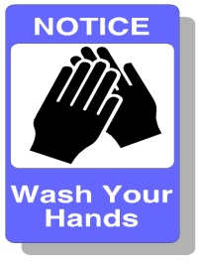

WHEN:
When in doubt, wash. In general, you should always wash your hands:
- before putting on gloves and immediately after removing them
- before and after performing invasive procedures or touching a patient’s face or mouth
- after contact with wounds, secretions, mucous membranes, blood, and other body fluids
- after touching any object that is visibly contaminated or likely to be contaminated with secretions or body fluids
- before and between direct contacts with different patients
- before eating, drinking, smoking, applying makeup or handling contact lenses
- after eating, smoking, coughing, sneezing or using the toilet
- if you touch blood, body fluids, or secretions when caring for one patient, you should wash your hands before proceeding to another care activity for the same patient.
WHERE:
At a sink with running water, soap and single use towels. When that is not available, use an appropriate antiseptic hand cleanser or antiseptic towelettes --- as a temporary measure only. You should wash your hands with soap and running water as soon as possible.
Use of an alcohol based product by rubbing it in is effective except for spore bacteria. (Ex. Clostridium difficile [C-diff])

HOW:
Handwashing:
- Wet hands with water,
- Apply soap
- Vigorously rub together all surfaces of lathered hands for at least 15 seconds
- Rinse hands thoroughly under a stream of water
- Dry hands completely with a clean, dry paper towel
- Use a dry paper towel to turn the faucet off.

Handrubs: recommended by CDC

- Apply to palm of one hand

- Rub hands together covering all surfaces until dry

- Volume: based on manufacturer
KEY TO THE CHAIN OF INFECTION

1. INFECTIOUS AGENT (PATHOGEN) MUST BE PRESENT
- in the environment, on or within bodies of animals or people

2. RESERVOIR
- where pathogens multiply
- people, equipment, water, food, body tissues, excreta, body fluids, contaminated objects
- to multiply, pathogens need the presence or absence of O₂, light or darkness, compatible temperature, moisture, form of nourishment.

3. PORTAL OF EXIT
- pathway for pathogen
- respiratory tract - nose and mouth
- GI tract - vomiting, feces
- GU tract – urine
- wound drainage

4. MEANS OF TRANSMISSION
- Contact
- direct - touching, droplet (cough or sneeze)
- indirect - contaminated line, equipment, etc.
- Vehicles
- substances in or on which pathogens are conveyed
examples: food, H₂O, blood, semen, vaginal secretions, urine.
- Airborne
- carried on dust particles surrounded by moisture and suspended in air

- INTERVENTION MOST OFTEN EFFECTIVE AT THIS LINK IN THE CHAIN
- Handwashing is the most effective intervention technique.

5. PORTAL OF ENTRY
- Pathogen enters into body
- orifices - respiratory, GI, GU, blood (transfusion)
- non-intact skin

6. SUSCEPTIBLE HOST
- The person in whom organism is present.
- In some people, the level of pathogens never reaches a level high enough to cause an active infection. However, some people, called carriers, harbor the pathogen and can pass the infection to others
- Some people are more susceptible to infection than others.
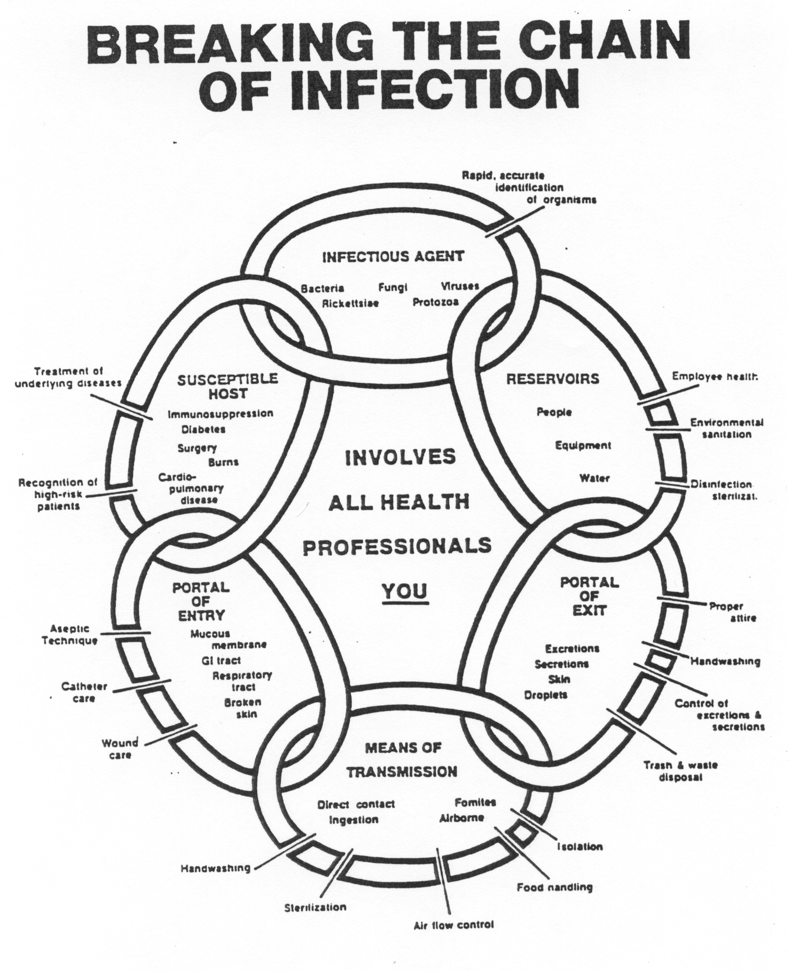
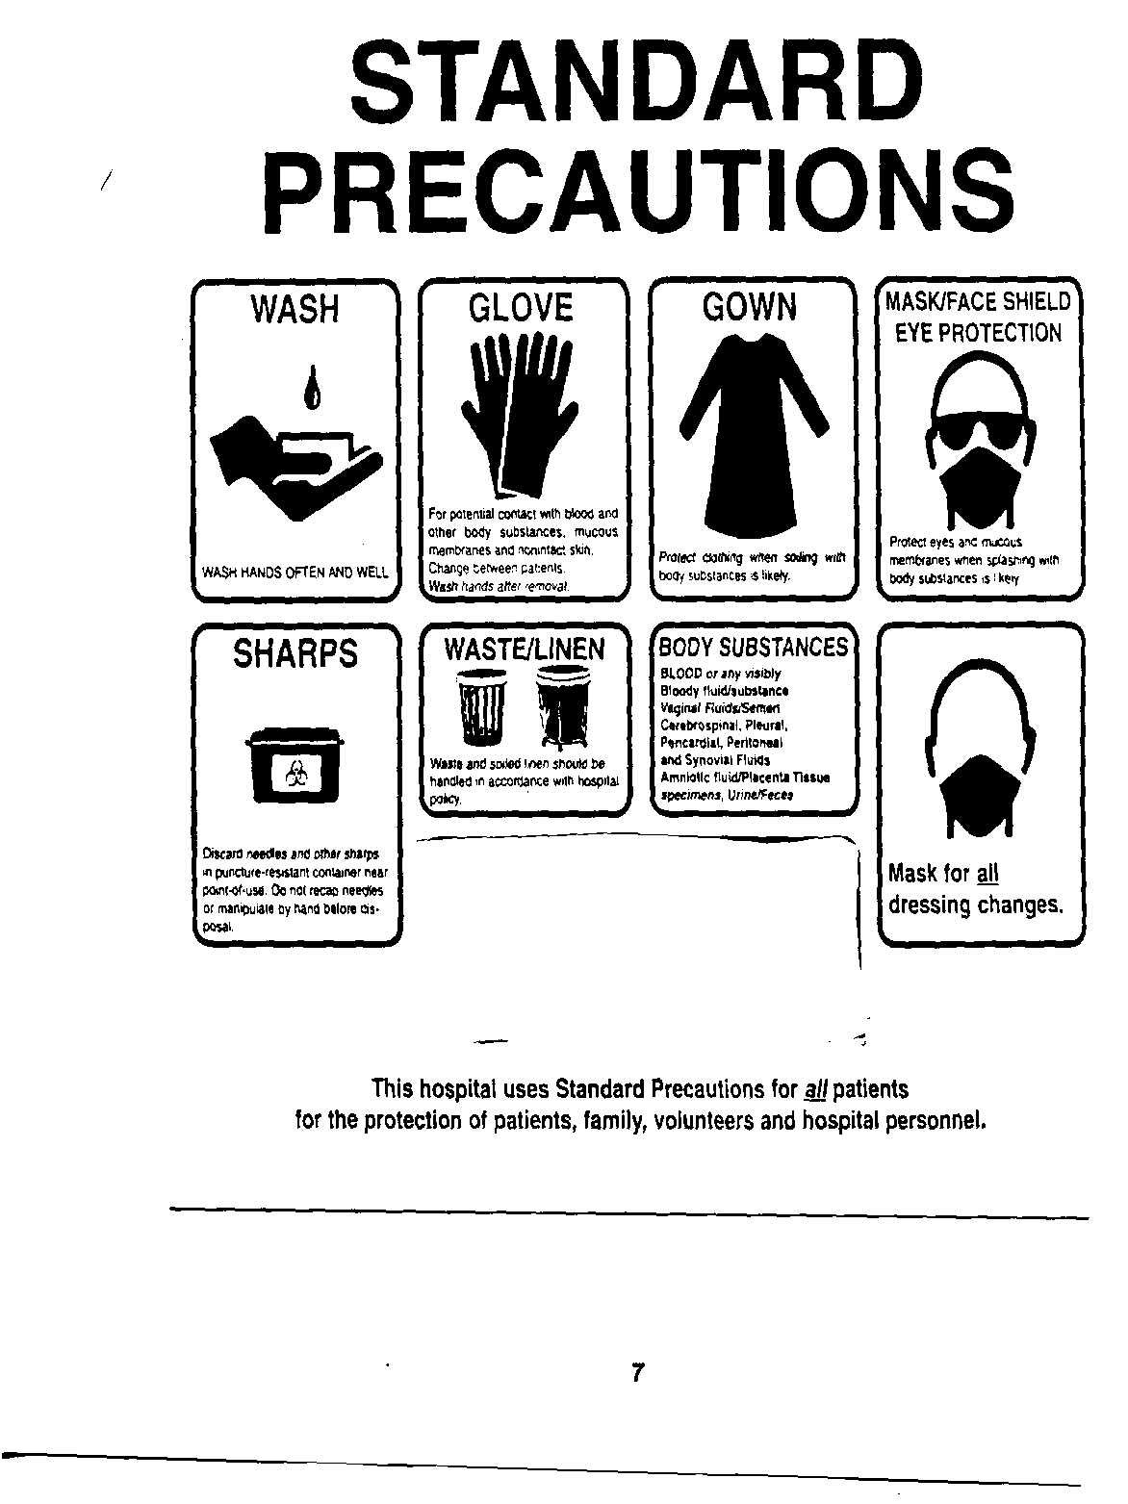
OSHA Bloodborne Pathogen Standard

The OSHA Bloodborne Pathogen Standard, which became federal law on December 6, 1991, is aimed at prevention or reduction of occupational exposure to blood or other potentially infectious material. This law provides standards that must be followed to protect health care workers against exposure to disease that can be transmitted by blood or body fluids, especially Hepatitis B and HIV.

The Bloodborne Pathogen Standard consists of six key provisions:

I. Written Exposure Control Plan - This plan tells employees of a health care agency its procedures for preventing or reducing their exposure to blood/body fluids.

II. Methods of Compliance

A. “Standard Precautions” - means protecting yourself against contact with ALL blood/body fluids from ALL patients.

B. Personal Protective Equipment - PPE means the equipment which a health care institution makes available to employees to protect themselves from contact with blood/body fluids. Examples include gowns, gloves, masks, resuscitation masks, eye protection.

Personal protective equipment appropriate to the task must be worn whenever contact with blood/body fluids is reasonably anticipated. Personal protective equipment must be disposed of properly at the site of use. In addition, sharps disposal containers are available in the appropriate locations throughout the health care setting. Do not recap, bend, break needles - place needle and syringe in sharps container immediately after use.

C. Handwashing - Handwashing facilities are readily available in all areas of the representative health care institutions. HANDWASHING IS THE SINGLE MOST IMPORTANT THING YOU CAN DO TO PREVENT THE SPREAD OF INFECTION. Wash hands before and after use of personal protective equipment and immediately after contact with blood/body fluids.

D. Safe Work Practices - Eating, drinking, smoking, applying cosmetics or lip balm and handling contact lenses are prohibited in work areas where there is a reasonable likelihood of occupational exposure. Food and drink shall not be kept in refrigerators, freezers, shelves, cabinets or on countertops or bench tops where blood or other potentially infectious materials are present. All procedures involving blood or other potentially infectious materials shall be performed in such a manner as to minimize splashing, spraying, spattering and generation of droplets of these substances.
Mouth pipetting/suctioning of blood or other potentially infectious materials is prohibited.

E. Use only Safety needles to prevent potential needle sticks with contaminated blood.
DO NOT RECAP NEEDLES.

If you send equipment away for servicing, you must decontaminate equipment before you send it. If decontamination is not feasible, use biohazard label and write on the label which part of equipment remains contaminated and attach label to equipment.

E. Housekeeping - There is a schedule for cleaning and decontamination of all facilities. The standard forbids clean-up of broken glass by hand and addresses proper clean-up of spills of blood/body fluid.

III. Hazard Communication - This involves the use of labels and signs or color-coding to make employees aware of the presence of blood or other potentially infectious material. Below is the Biohazard symbol - anytime you see the symbol be aware of the presence of infectious material.

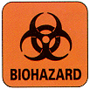

Examples of color-coding include:

1. Red is used for plastic bags containing infectious waste, which is defined as anything disposable which is contaminated with blood/body fluids.

2. Yellow is used for impervious laundry bags containing laundry which is contaminated with infectious material.

Exception: All specimens are placed in biohazard bags. Specimen containers do not need to be labeled as "Biohazard" as long as they remain in the facility and as long as all employees recognize them as containing potentially infectious material. Be aware that all specimen containers contain potentially infectious material.

IV. Information & Training - All employees, students, and volunteers in a health care setting must receive training about the OSHA Bloodborne Pathogen Standard at the time of employment and annually thereafter.

V. Record keeping - This provision involves Medical Records and Training Records.

VI. Compliance Monitoring - The OSHA Bloodborne Pathogen Standard states that the employer
will assure compliance with required measures.

Tuberculosis Prevention and Control

1. Tuberculosis Transmission
Tuberculosis is caused by the bacteria Mycobacterium tuberculosis. It is transmitted by airborne droplet nuclei. When a person with infectious tuberculosis coughs, sneezes, talks or sings, he may expel tubercle bacilli into the air. If a health care worker inhales those bacilli, s/he is exposed to tuberculosis and could be infected. A person with a normally-functioning immune system can isolate the bacilli and probably will not become infectious. However, when the immune system is not functioning properly, the person may become infectious; that is, s/he can transmit the tuberculosis bacillus to others.

2. Signs and Symptoms of Tuberculosis
Signs and symptoms of tuberculosis include cough, fever, weight loss, night sweats and loss of appetite.

3. Medical Surveillance and Therapy
All employees/students are required to have annual TB skin tests, using P.P.D. (purified protein derivative). A positive P.P.D. means that a person has been exposed to tuberculosis sometime in his lifetime and carries the TB antibodies. A person with a positive P.P.D. and no symptoms probably cannot transmit tuberculosis to others.

An employee who converts from a negative P.P.D. to a positive P.P.D. does need a medical evaluation, chest x-ray and examination by M.D. to decide if preventive therapy is necessary. An average of 1 in 10 persons infected with Tuberculosis will go on to develop the tuberculosis disease without preventive therapy. Therapy for tuberculosis can include treatment with medication, such as INH, Rifampin, Ethambutol and others, for 6 to 12 months. The patient must be closely monitored by an M.D. during therapy to observe for medication side effects. Pregnant women should be evaluated by an M.D. to determine risks versus benefits of preventive therapy during pregnancy.

4. Respiratory Protection
Each employee/student, upon being assigned to an area that requires the use of respirators, must be instructed by the supervisor, as to his responsibilities in the respiratory protection program. S/he will be instructed in use, need, care and limitations of the respirators required when in an area that necessitates the use of respirators.
Respirators cannot be worn by students until the medical self evaluation has been completed and fit testing has been performed by the appropriate healthcare facility.

SAFETY
Objectives
Upon completion of the Safety section, you will be able to:

1. State why safety is important in health care settings.
2. Describe importance of orientation to fire and electrical safety for each healthcare facility.
3. Describe the activities associated with the terms "RACE" and "PASS."
4. Identify key HAZ-COM terminology.
5. Describe the information available on an MSDS.
6. Identify and give examples of electrically-susceptible patients.
7. Describe the student's role in a disaster.
8. Describe the student's role in a medical emergency.

General Safety Practices

1. Safety is every health care worker's responsibility. Every worker must:
a. Report any unsafe condition or act that is observed.
b. Report any foreign material on floors or remove it at once to prevent injury to others.
c. Report any defective or damaged equipment immediately.
d. Walk, do not run - especially in halls and on stairs. Keep to the right, using special caution at intersecting corridors.
e. Know the fire safety plan of your assigned facility. Know the location of fire alarms and extinguishers and how to use them.
f. Become familiar with relevant work procedures and safe work practices.
g. Open doors slowly, using the handle or push plate. Be sure the other side is clear before opening doors.
h. Horseplay and practical jokes often result in serious injury. The workplace is no place for them.
i. No health care worker is expected to take chances or endanger themselves or others in the performance of his/her job duties. Do not take chances or guess! When in doubt, ask your student liaison or the supervisor on duty to explain any assigned job or task.
j. Safety hazards create an increased risk for patients in the health care facility because they are unfamiliar with the surroundings.

2. Slips and falls are often caused by poor housekeeping habits. In order to help eliminate slips and falls, all health care workers should observe the following:
a. Do not block doorways, elevators or entrances with equipment.
b. Observe “Wet Floor” signs which indicate “CAUTION.”
c. Take personal responsibility to alleviate slipping or tripping conditions anywhere on the floor or stairways, and to report principal hazards to your student liaison or the supervisor on duty.
d. Do not use chairs, boxes, etc. for climbing. Always use a ladder.
e. Approach corridor intersections and elevators slowly.
f. Report unsafe conditions immediately to your student liaison or the supervisor on duty.

3. Back injuries can and should be avoided. Keep in mind the following suggestions:
a. Lifting is the most common cause of back injury among health care workers.
(1) Keep the load close to your body.
(2) Bend your knees and hips.
(3) Use your abdominal muscles when you lift; they help support your back.
(4) Use your legs and buttocks to lift.
(5) Avoid twisting.
b. Pushing and pulling large objects can be as hard on your back as lifting.
(1) Whenever possible, push rather than pull. You can push twice as much as you can pull without strain.
(2) Use both arms.
(3) Tighten your abdominal muscles when pushing.
c. Bending also needs to be done correctly.
(1) Kneel down on one knee.
(2) Bend knees and hips, not your back.
(3) To lean forward, move your whole body, not just your arms.
d. While performing repetitive motions, such as stacking linen, always remember your back.
(1) Keep loads small.
(2) Turn your whole body instead of twisting.
(3) Lift with your arms and legs, not your back.
(4) Tighten your abdominal muscles to lift.
e. Reaching, especially in high places, can cause an injured back if you reach too far or lift too much weight. Remember:
(1) Reach only as high as is comfortable and use a stool if you need it.
(2) Test the weight of the load before lifting it by lifting the corner of the item to be lifted.
(3) Use your arms and legs to do the work. Tighten your abdominal muscles as you lift.
f. Always use good body mechanics.
(1) Keep knees bent - make your legs work harder to reduce stress on your back.
(2) Avoid twisting - move your torso, shoulders and hips as one unit.
(3) Keep loads close to your body to minimize the effect of weight.
g. To reduce stress on your back, a variety of devices can assist and make your job easier. Examples are:
(1) Draw-Sheets (3) Trapeze Bars (5) Transfer Belts
(2) Slide Boards (4) Mechanical Lifts

4. As a health care worker, you may come in contact with electrical and mechanical equipment. These are potential sources of injury to the inexperienced or untrained worker. The following are general practices to reduce accidents:
a. Never operate a machine or a piece of equipment until instructed in its safe operation.
b. Make absolutely certain that all personnel are clear of the machine or equipment before it is started. Walk around it, if necessary, and/or give the proper warning signal before start-up.
c. Turn off the equipment before machine repairs or adjustments are made. There are no exceptions to this practice.
d. Personal protective equipment, such as gloves, safety glasses, ear protection, hard hats, safety clothing, etc. may be required in certain operations. Your supervisor should provide the personal protection equipment necessary for each job.
e. If equipment appears to be malfunctioning or has been damaged by a fall, contact your student liaison or the supervisor on duty.

5. At times you may be required to handle various materials. Keep the following suggestions in mind when you do:
a. Avoid handling containers with protruding nails, slivers, sharp metal trim, jagged edges, burrs or rough surfaces. Ask to have them repaired or disposed of.
b. Keep fingers and feet away from pinch points, especially when setting down materials, passing through doorways or closing drawers and doors.
c. Wipe off greasy, wet, slippery or dirty objects before trying to handle them.
d. Medical utility carts are designed for patient equipment and office supplies. Avoid using them for other uses.
e. Needles and other sharp objects may be a source of infectious disease. Develop the habit of immediately disposing of such objects in the nearest sharps disposal container. Do not attempt to recap, break or destroy them in any way. Needle stick injuries require immediate follow-up.
f. Proper safety devices should be used when breaking glass ampules.
g. Do not reach into wastebaskets.
h. Be alert to the potential for burns while handling hot liquids or materials.

Electrical Safety

1. A study shows that approximately 75% of all equipment hazards that eventually result in an electrical shock are visible for a period of time prior to the accident.

2. Frayed or damaged electrical cords or extension cords must not be used until repaired or replaced.

3. If a "tingle" or shock is felt, unplug the equipment and report it to your student liaison or the supervisor on duty.

4. When disconnecting equipment from the wall outlet, grasp the cord cap and tug gently. Don't grab the power cord and yank on it.

5. Keep cables and cords protected from oil, chemicals, liquids, and sharp objects to prevent damage.

6. Arrange equipment cords and cables away from foot traffic. Keep them off of stairs and out of aisles.

7. Unless specifically part of the job assignment, never open panel boxes, reset circuit breakers or change fuses. Report any suspected electrical problem to your student liaison or the supervisor on duty.

8. Electrically-operated beds have been the cause of many accidents in hospitals and long-term care facilities. Make sure electric cords from the beds do not pose a trip hazard. To prevent electrical shocks and fires, check for damaged plugs and/or pinched wires on the beds. Report any problems to your student liaison or the supervisor on duty.

9. In case of an electrical fire, do not use a water fire extinguisher; use an ABC-rated extinguisher.

10. Do not allow equipment to roll over power cords.

11. All cord-connected, electrically-powered appliances used in the patient vicinity should be provided with a three-wire power cord and a three-pin grounding type plug. Exception: Double-insulated appliances are permitted to have two conductor cords. Household or office appliances not commonly equipped with grounding conductors in their power cords are generally permitted provided they are not located within the patient vicinity.

12. Portable space heating devices are prohibited in all health care and ambulatory health care occupancies. Exception: Portable space heating devices shall be permitted to be used in non-sleeping staff and health care worker areas when the heating elements of such devices are limited to not more than 212°F(100°C).

13. If a medical instrument or equipment is malfunctioning, has been dropped or has had liquid spilled on it, turn the power off, disconnect the power cord from the wall outlet and report it to your student liaison or the supervisor on duty.

14. Red emergency electrical outlets are located throughout the units in most if not all health care facilities. These can be used at any time and are the only outlets that will supply power during an electrical power outage. These outlets should be used at all times for critical equipment such as patient life support systems.

Fire Safety

1. Fire extinguishers are available in designated areas of each facility. Learn the location and proper use of fire extinguishers and alarm pull boxes.

2. Passageways and work areas around fire extinguishers must be kept clear at all times.

3. Extinguishers that appear to have been used or tampered with should be reported to your student liaison or the supervisor on duty immediately.

4. In many health care facilities, no open flame or smoking is permitted. Learn the policy/location regarding smoking at the facility to which you are assigned.

5. Exit doors shall not be obstructed. Know how to exit from the work area.

6. Respond to and report fires according to agency policy. Do not risk trying to extinguish a fire before signaling for help.

7. Be alert in preventing and recognizing fire hazards.

8. Know fire and evacuation plans for the work area to which you are assigned. Avoid using the elevators - keep them free for firefighters and emergency equipment.

9. ASK YOUR LIAISON OR THE SUPERVISOR ON DUTY WHETHER OR NOT YOU NEED TO KNOW THE LOCATION OF THE NEAREST OXYGEN SHUT-OFF VALVE AND HOW TO USE IT. Special precautions are required when a patient is using oxygen because oxygen supports rapid combustion.

10. The acronyms below assist health care workers to remember the procedures for operating a fire extinguisher and responding to a fire.

PROCEDURE WHEN YOU DISCOVER A FIRE

Remember R.A.C.E.
R - RESCUE anyone in immediate danger.
A ALARM according to the instructions provided by the facility to
which you are assigned. Provide the exact location of the fire.
Send a runner if necessary to alert the rest of the facility.
C - CONTAIN the fire. Close the door of the room.
E - EXTINGUISH the fire, if possible, using fire extinguishers or heavy
blankets.

PROCEDURE TO OPERATE A FIRE EXTINGUISHER

Remember PASS

P - PULL the ring pin
A - AIM the nozzle at the base of the fire
S - SQUEEZE the handle,
S - SWEEP side to side at the base of the fire

Radiation Safety

Not every facility has a need to be concerned about radiation safety; however, if you are assigned to one of the few facilities that does, it is important that you learn any safety procedures related to the use of radiation. The procedures that follow are those that have been established by Cheyenne Regional Medical Center and are presented here as an example.

1. Cheyenne Regional Medical Center has a Radiation Safety Committee to monitor that radioactive materials are being used in a safe fashion and to review the policies and procedures annually. Any questions about radiation safety should be brought to the attention of the Radiation Safety Committee, Radiation Safety Officer or the Nuclear Medicine Department.

2. General radiation safety guidelines include:

a. Radiation exposure is lowered by limiting time close to a radioactive source, increasing distance from the source, or by shielding (as with lead, walls, doors, etc.).
b. Implant therapy patients (inpatients treated with high-dose radioactive materials) require special monitoring, special care to avoid contamination, and limits on time spent with the patient by either nursing personnel or visitors. These patients are on the oncology unit in a specially marked room. Any questions regarding their care can be answered by the nursing staff, as noted on the chart, or by the Radiation Oncology Department/Technological staff. Do not enter one of these rooms without permission from the nursing staff.

c. Diagnostic patients (in or outpatients treated with lower doses of radioactive materials do NOT require special handling unless specifically requested by Nuclear Medicine and unless it is necessary to clean up after an incontinent patient in which case gloves must be worn.
d. Any questions about contamination or radioactive spills should be brought immediately to the attention of the Nuclear Medicine Department. DO NOT proceed with clean-up or decontamination without notifying Nuclear Medicine first.
e. DO NOT enter ANY room or area posted with a radioactive symbol.
f. Patients who have had X-rays or CT scans are NOT radioactive.
g. Health care workers working directly with radiation emitting machines or radioactive materials follow special safety procedures which do not apply to general hospital health care workers. Health care workers in Radiography, Nuclear Medicine and Radiation Oncology must be aware of and follow these procedures correctly.

h. This is an example of the radiation symbol. It will be black or purple on a yellow background and may be found on packages, doors and containers.
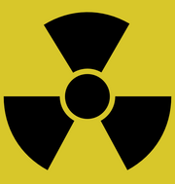

Hazardous Communication
There are many potentially hazardous substances in a hospital or long-term care workplace. In many cases, the chemicals with which you deal with may be no more dangerous than those you use at home. But, in the workplace, exposure is likely to be greater, concentrations higher, and exposure time longer. Therefore, the potential for injury is greater on the job.

The Occupational Safety and Health Administration (OSHA) have issued a regulation to help control chemical exposure on the job. The regulation is called the Hazard Communication Standard, but is commonly called Haz-Com or the "Right to Know Law”.

The standard states that you have a right to know what chemicals you are working with or around. Its intention is to make your work environment a safer place. So, it is important that you have some basic understanding of the Standard and the rights it grants you.

The Hazard Communication Standard requires that all chemicals in your workplace be fully evaluated for possible physical or health hazards. And, it mandates that all information relating to these hazards be made available to you.

Physical hazards are exhibited by certain chemicals due to their physical properties, e.g.
flammability, reactivity. These chemicals fall into the following classes:

* flammable liquids or solids * unstable materials
* combustible liquids * watch reactive materials
* compressed gases * organic peroxide
* explosives * oxidizers
* pyrophoric materials (may ignite spontaneously in air at temperatures
of 130° F or below)

A health hazard is that which occurs when a chemical brings about an acute or chronic health effect on exposed health care workers. It can be an obvious effect, such as immediate death following inhalation of cyanide. But, a health hazard may not necessarily cause immediate, obvious harm or make you sick right away. You may not see, feel or smell the danger.

An acute health effect usually occurs rapidly, following a brief exposure. A chronic health effect is long, continuous and follows repeated long-term exposure.

Some examples of chemicals which exhibit health hazards are:

Type of chemical Specific example of type

CARCINOGENS ..........................formaldehyde or benzene
TOXIC AGENTS ..........................lawn and garden insecticides, arsenic compounds
REPRODUCTIVE TOXINS ........thalidomide or nitrous oxide
IRRITANTS ...................................bleaches or ammonia
CORROSIVES ...............................battery acid or caustic sodas
SENSITIZERS ...............................creosote or epoxy resins
ORGAN-SPECIFIC AGENTS ....sulfuric acid (affects skin) or asbestos (affects lungs)

The Hazard Communication Standard does not apply to hazardous waste regulated by the EPA, tobacco products, wood or wood products, or food, drugs or cosmetics intended for personal consumption.

Material Safety Data Sheets

You are not expected to remember everything about the hazardous chemicals you work with at your assigned facility. Instead, you can find that information by reading the Material Safety Data Sheet (MSDS). The next two pages provide an overview of how to read and understand an MSDS. It is your responsibility to determine the location of the MSDS in your assigned facility.

How to use and understand Material Safety Data Sheets

Material Safety Data Sheets (MSDS) are designed to help you understand how to work safely with chemicals in your work area. Although Material Safety Data Sheets may vary in appearance and length, most MSDS will have approximately 8 to 10 sections which explain the proper ways to use, handle, and store chemicals in your work area. In addition, MSDS provide information regarding the health hazards associated with the use of chemicals, the precautionary measures to follow, and the emergency procedures for spills, fire, and first aid.

The following blank MSDS sample will help you to become familiar with using MSDS and the different sections found on most MSDS. The MSDS can be a very important tool which can help you as an employee to understand the dangers associated with the chemicals in the work area and most importantly, the proper ways to protect yourself and other employees.
Be sure to read the MSDS for each chemical in your work area before attempting to work with a chemical you are unfamiliar with. Remember to always consult with your supervisor if you have specific questions concerning MSDS or chemicals in your work area.

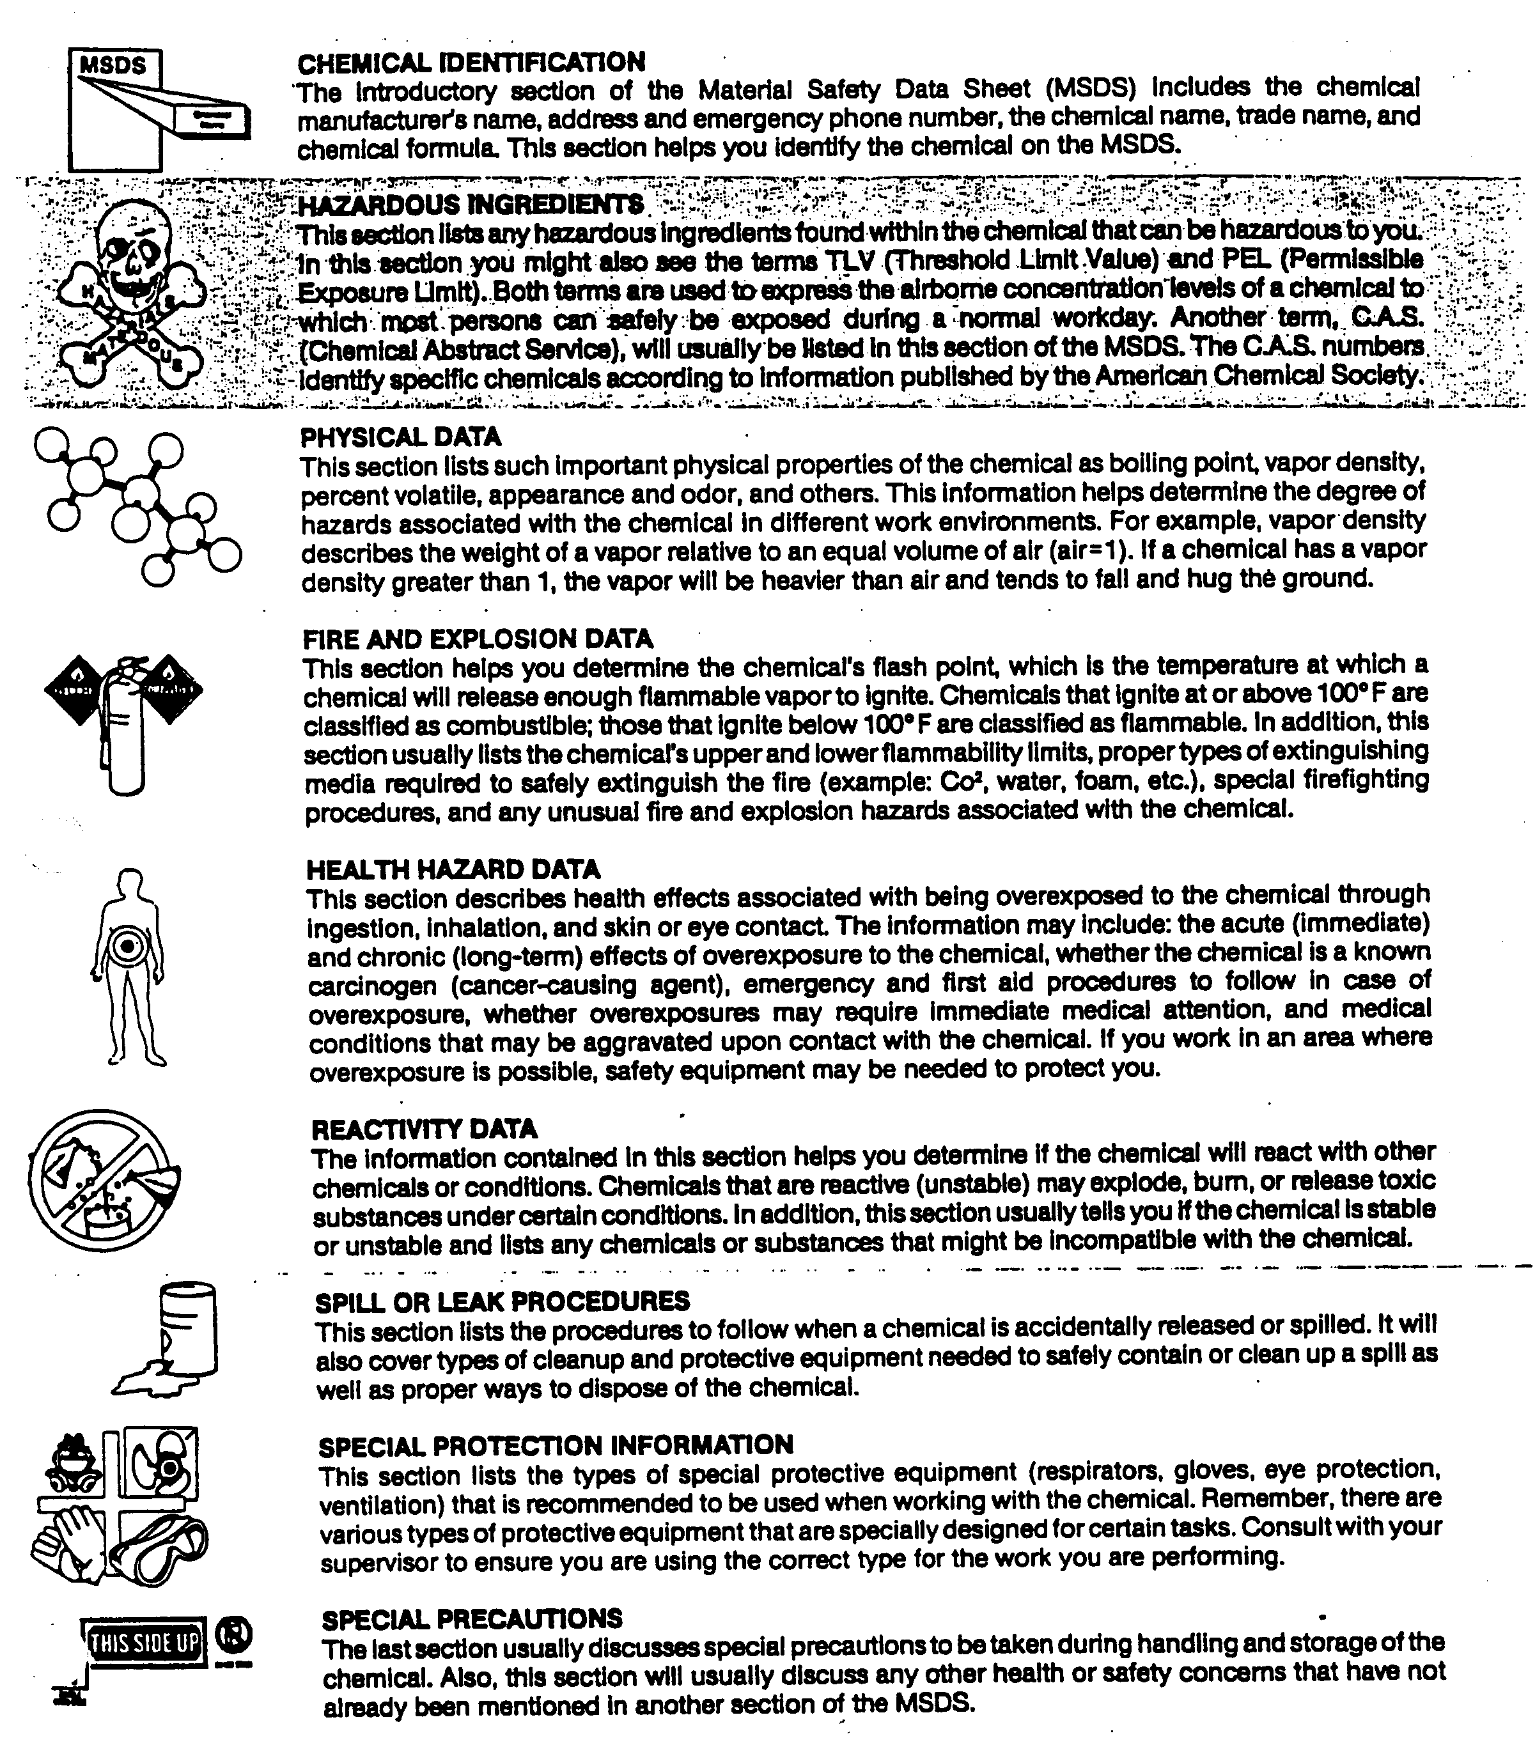
Labels and Labeling Requirement

Containers of hazardous chemicals must be labeled in English. It is required that labels contain the following information:
- identity of the hazardous chemical
- appropriate hazard warnings
- name and address of the chemical manufacturer, importer or other responsible party

Written Hazard Communication Program

Each health care facility is required by the Hazard Communication Standard to have developed and implemented a written Hazard Communication Program. This program details how the facility will meet the standard's requirements for labels, MSDSs and health care worker information and training. It is your responsibility to inquire about the HAZ-COM program at your facility. According to the Hazard Communication Standard, you are to be informed of the requirements of the Standard and of any operations in the work area where hazardous chemicals are present. In addition, you also need to be informed of the location and availability of the facility's written hazard communication program, and even more important, the location and availability of the MSDS file.

Occupational Exposure

All exposures must be reported immediately to your liaison and the supervisor on duty at your assigned facility.

An occupational exposure is a specific eye, mouth, other mucous membrane, non-intact skin, or parenteral contact with blood or other potentially infectious material that results from the performance of a health care worker's duties.

Potentially infectious materials are all human body fluids, including semen, vaginal secretions, cerebrospinal fluid, synovial fluid, pleural fluid, pericardial fluid, peritoneal fluid, and amniotic fluid. This also includes any body fluid that is visibly contaminated with blood and all body fluids in situations where it is difficult or impossible to differentiate between body fluids and blood.

Non-intact Skin is considered to be a break in the skin and provides access to the vascular system.
Certain types of exposure require reporting. These are:
1. Puncture of skin with a needle, sharp instrument, or object which has been soiled with blood/body fluids.
2. Splash or aerosolization of potentially infectious material onto the mucous membrane of the mouth, nose or eye.
3. Exposure of non-intact skin to blood/body fluids.
4. Human bite.
5. Mouth-to-mouth resuscitation without use of a protective mask system.

First Aid for Exposure to Blood and Body Fluids

1. Needlestick injury, cuts, scratches, or human bites involving blood or body fluids:

a. If near a sink, immediately rinse the injured area in flowing, cold tap water.
b. Wash the injured area for 10 minutes with soap and water or a disinfectant towlette if soap is not available. Rinse with water.
c. Cuts, scratches, or bites contaminated with potentially infectious materials should be pulled apart gently with a gloved hand to open the tissue. Treat as above.
d. Blot the area gently, cover the wound, and seek medical assistance immediately through your agency procedure.

2. Eye, mouth, and mucous membrane exposures:

a. Splashes of potentially infectious materials to the face, eyes, nose and/or mouth or to non-intact skin warrants immediate, gentle flushing of the eye, nose, mouth, or skin lesion with large amounts of room temperature tap water for 10 minutes if available. The goal is to promote rapid dilution of the material without irritating the mucous membranes or underlying tissues. The nose or abraded skin, BUT NOT THE EYE, can be rinsed with dilute soap water as a gentle wash solution when feasible. The area should be rinsed with water.
- Seek medical assistance immediately.

Post-Exposure Flow Sheet

- Exposure to blood or body fluids occurs.
- Apply first aid immediately
- Notify your supervisor or Student notifies instructor immediately.
- See Employee Health or contact the emergency room immediately. Student or instructor contacts the Emergency Room, Student Health, Family Practice Center, or other appropriate health care provider.
- Report to one of the above facilities to receive evaluation and treatment.
- Completes appropriate agency Variance report (aka Occurrence or Incident Report) within 24 hours of exposure.
Appropriate paperwork, as required by the college/university, needs to be completed and handed in to the clinical instructor or designated person as soon as possible.

Incident Report/Variance Report

Through an effective reporting system, loss prevention and loss control programs are maintained as part of a health care facility’s Quality/Risk Management activities. Incidents/variances involving patients, health care workers, visitors and physicians should be reported and any necessary follow-up steps should be taken. It is important that you become familiar with your assigned facility’s reporting system.

An incident/variance is:
- Any occurrence which would have harmed the patient whether it did or not.

- Any occurrence with or without injury which left the patient or his/her significant other perceiving, rightly or wrongly, that s/he had been slighted, neglected, mistreated or injured.

- Any unusual occurrence.

- Any deviation from the commonly anticipated medical outcome.

Safe Medical Device Act

The Safe Medical Device Act requires hospitals to report to the FDA when information is received that reasonably suggests that a medical device may have caused or contributed to the death, serious injury or serious illness of a patient or other individual. Hospitals, under their Risk Management Program, review all incident reports. It is imperative that, if a piece of equipment is involved in an incident involving a patient or other individual, you advise your student liaison and the supervisor on duty as soon as possible.

Your Role in a Medical Emergency or Disaster

The following steps should be taken if you are involved in a medical emergency:
- Activate the Facility’s Emergency Medical Response Procedures for cardiac arrest
- Begin CPR if you are certified and are first on the scene;
- Follow the instructions given by your facility’s personnel or the protocol established by that facility.

HEALTH INFORMATION PORTABILITY AND ACCOUNTABILITY ACT
(HIPAA)

Objectives

Upon completion of the HIPAA section, you will be able to:

1. Define and discuss confidentiality as it pertains to health care facilities;

2. Identify at least four examples of confidential information;

3. Identify at least two examples of general information about a patient that can be released;

4. Define invasion of privacy as it applies in a health care setting;

What is Patient Confidentiality?

Confidentiality refers to the protection of patient privacy in written, oral and electronic communication. It is keeping information about patients’ health care PRIVATE. Patient confidentiality protects patients, employees, and the health care facility. Examples of confidential information are:

- details about illnesses or conditions

- information about treatments

- photographs or videos of patients

- a health care provider’s notes about a patient

- conversations between a patient and health care provider

Even general patient information is confidential. Employees/students facility may not release general information which includes the patient’s name, date of admission, home town or city, gender, and general condition (fair, serious, etc.) Written materials such as signs, schedules, report boards or assignments sheets/boards containing patient information can not be in areas that are accessed by the general public.

When in doubt about anything that may be related to a patient’s right to confidentiality, ask your student liaison or the supervisor on duty.

Patient information should be discussed only with those who have a need to know, namely, those involved in the patient’s care. Discussion needs to occur in areas where information will not be overheard by others. It is NEVER appropriate to discuss patients in areas such as the cafeteria, elevator or outside the facility. It is against the law for patients’ health records to be made public without the patients’ written consent. Both the law and job standards require confidentiality. Failure to comply may lead to disciplinary or legal action against you, your school, and/or your assigned facility.

Invasion of privacy involves revealing confidential information without permission to someone who is not entitled to know that information. A few exceptions to maintaining confidentiality exist, such as situations related to child abuse and gunshot wounds. If suspicions arise related to abuse or gunshot wounds, ask your student liaison or the supervisor on duty.

State laws vary related to who does the reporting and to whom it must be done.

HIPAA requires that all health care facilities establish policies regarding patient confidentiality and medical records. It is your responsibility to inquire about these policies at each of the facilities to which you are assigned and to determine where and how to access them.

Tips for Protecting Patient Confidentiality

1. Follow proper procedures.
2. Get proper authorization. Protect all records.
4. Don’t talk about patients in public.
5. Use care with phones and fax machines.
6. Be alert to your own breaches in confidentiality as well as that of your peers.

PATIENT AND RESIDENT RIGHTS

Objectives

Upon completion of this section, you will be able to:

1. Define the term OBRA;

2. Identify generalized resident rights and responsibilities.

OBRA

In the Ombudsman Budget Reconciliation Act (OBRA) passed by Congress in 1981 it states the need for a patient or long-term care resident to have established rights while a patient or resident in a health care facility, along with other social issues. As with patient confidentiality, it is your responsibility to inquire about the patient/resident policies at each of the facilities to which you are assigned and to determine where and how to access them.

Resident Rights

In general, patient and resident rights adopted by health care facilities are reflected in the following statements:

1. You, the patient or resident, have the right to considerate and respectful care.

2. You have the right to and are encouraged to obtain from physicians and other direct caregivers, relevant, current, and understandable information concerning diagnosis, treatment and prognosis.

Except in emergencies, when you lack decision-making capacity and the need for treatment is urgent, you are entitled to the opportunity to discuss and request information related to the specific procedures and/or treatments relating to your care, the risks involved the possible length of your recuperation, and the medically reasonable alternatives and their accompanying risks and benefits.

You have the right to know the identity of your physicians, nurses, and others involved in your care, as well as when those involved are students, residents, or other trainees. You also have the right to know the immediate and long-term financial implications of treatment choices, insofar as they are known.

3. You have the right to make decisions about the plans of care prior to and during the course of your treatment and to refuse a recommended treatment or plan of care to the extent permitted by law and facility policy. You also have the right to be informed of the medical consequences of this action. In case of such refusal, you are entitled to other appropriate care and services that the facility provides or the right to transfer to another facility. The facility will notify you of any policy that might affect your choice.

4. You have the right to have an advance directive (such as a living will, health care proxy, or durable power of attorney for health care) concerning treatment or designating a surrogate decision maker with the expectation that the hospital will honor the intent of that directive to the extent permitted by law and facility policy.

Under Wyoming state law, you as a patient/resident have a right to make informed medical choices and to maintain a copy of an advance directive within your medical record. You have the right to timely information about facility policy that may limit its ability to implement fully a legally valid advance directive.

5. You have the right to every consideration of your privacy concerning your own medical care program. Case discussion, consultation, examination, and treatment are confidential and should be conducted discreetly. Those not directly involved in your care must have your permission to be present.

6. You have the right to expect that all communications and records pertaining to your care will be treated as confidential by the facility, except in cases such as suspected abuse and public health hazards when reporting is permitted or required by law. You have the right to expect that the facility will emphasize the confidentiality of this information when it releases it to any other parties entitled to review information in those records.

7. You have the right to review the records pertaining to your medical care and to have the information explained or interpreted as necessary, except when restricted by law.

8. You have the right to expect that, within its capacity and policies, this facility will make reasonable response to the request of a patient for appropriate and medically indicated care and services. We will provide evaluation, service and/or referral as indicated by the urgency of your case. When medically appropriate, and legally permissible, or when a patient/resident has so requested, a patient/resident may be transferred to another facility. The institution to which the patient is to be transferred must first have accepted the patient/resident for transfer. The patient/resident must also have the benefit of complete information and explanation concerning the need for, risks, benefits, and alternatives to such a transfer.

9. You have the right to ask and be informed of the existence of business relationships among the facility, educational institutions, other health care providers, or payers that may influence your treatment and care.

10. You have the right to consent to or decline to participate in proposed research studies or human experimentation affecting care and treatment of requiring direct patient/resident involvement, and to have those studies fully explained prior to consent. A patient/resident who declines to participate in research or experimentation is entitled to the most effective care that the facility can otherwise provide.

11. You have the right to expect reasonable continuity of care when appropriate and to be informed by physicians and other caregivers of available and realistic patient/resident care options when facility care is no longer appropriate.

12. You have the right to be informed of facility policies and practices that relate to patient/resident care, treatment, and responsibilities. You have the right to be informed of available resources for resolving disputes, grievances, and conflicts, such as ethics committees, patient/resident representatives or ombudsmen, or other mechanisms available in the institution. You have the right to be informed of the facility’s charges for services and available payment methods.

Patient/Resident Responsibilities

The collaborative nature of health care requires that patients or their families/surrogates, participate in their care. The effectiveness of care and patient/resident satisfaction with the course of treatment/care, depends, in part, on the patient/resident fulfilling certain responsibilities. You, the patient/resident, have the responsibility:

1. to know and follow facility rules and regulations as outline in the facility handbook or equivalent;
2. to provide accurate and complete information about present complaints, past illnesses, hospitalizations, medications and other matters related to your health;
3. to talk with your physician and/or other appropriate personnel related to your health and care;
4. to notify your physician if you have implemented a change in your advance directive;
5. to let appropriate personnel and your family know if you feel you are receiving too many outside visitors;
6. to respect the privacy of your roommate(s);
7. to accept your financial obligations associated with your care;
8. to advise the appropriate personnel or patient/resident representative of any dissatisfaction you may have in regard to your care at this facility; and,

9. to be considerate of the rights of other patients/residents and facility personnel and to assist
in the control of noise, the number of visitors you receive, and to observe the facility’s no
smoking polices

MEMORIAL HOSPITAL OF LARAMIE COUNTY
d/b/a CHEYENNE REGIONAL MEDICAL CENTER
CONFIDENTIALITY AGREEMENT
It is the responsibility of all Memorial Hospital of Laramie County d/b/a Cheyenne Regional Medical Center (“HOSPITAL”) workforce members, as well as persons present at HOSPITAL for clinical experience purposes such as students, interns, faculty members and other persons participating in the training, to preserve and protect confidential patient, employee, and business information.
The federal Health Insurance Portability and Accountability Act (“HIPAA”), as well as State of Wyoming laws, govern the release of patients’ individually identifiable health information by hospitals and other health care providers and specify that such information may not be disclosed except as authorized by federal and state law or the respective patient or individual pursuant to an authorization in compliance with such laws.
Confidential patient information includes: Any individually identifiable health information in possession or derived from a provider of health care regarding a patient’s medical history, mental or physical condition or treatment, as well as the patient’s and/or the patient’s family members’ records, test results, conversations, research records, and financial information. Examples of information that would be protected under HIPAA include, but are not limited to:
• Physical, medical, and psychiatric records including paper, photo, video, diagnostic and therapeutic reports, laboratory and pathology samples;
• Patient insurance and billing records;
• Mainframe and department-based computerized patient data and alphanumeric radio pager messages;
• Visual observation of patients receiving medical care or accessing services;
• Verbal information provided by or about a patient; and
• Names, addresses, Social Security numbers, geographic information, birth dates, admission dates, discharge dates.

Confidential employee and business information includes, but is not limited to:
Employee home telephone number, address, electronic mail path;
• Spouse or other relative names;
• Social Security number or income tax withholding records;
• Information related to evaluation of performance;
• Other such information obtained from HOSPITAL records which, if disclosed, would constitute unwarranted invasion of privacy;
• Disclosure of confidential business information that would cause harm to HOSPITAL.

I understand and acknowledge that:
1. I agree to respect and maintain confidentiality of all discussion, deliberations, patient care records, and any other information generated in connection with individual patient care, risk management, and/or peer review activities.

2. It is my legal and ethical responsibility to protect, and I agree to protect, the privacy, confidentiality, and security of all medical records, proprietary information, and other confidential information related to HOSPITAL and its affiliates, including business, operational, employment, and medical information relating to HOSPITAL’s patients, members, employees, and health care providers.
3. I agree to only access or disseminate patient care information in the performance of my assigned duties and where required by or permitted by law, and in a manner which is consistent with officially adopted policies of HOSPITAL or, where no officially adopted policy exists, only with the express approval of HOSPITAL’s designated contact person or their designee. I agree to make no voluntary disclosure of any discussions, deliberations, patient care records or any other patient care, peer review, or risk management information, except to persons authorized by law to receive it in the conduct of HOSPITAL affairs.
4. HOSPITAL (administration, Privacy Officer, Security Officer, or Information Technology Department) may perform audits and reviews of patient records in order to identify inappropriate access.
5. My user identification (ID) is recorded when I access electronic records and I am the only one authorized to use my user ID. Use of my user ID is my responsibility whether used by me or anyone else. I will only access the minimum necessary information to satisfy my role or the need as requested by my Designated Faculty, HOSPITAL Contact Person, or their designee.
6. I agree to discuss confidential information only while at HOSPITAL and only as needed for cooperative education experience related purposes and to not discuss such information outside of HOSPITAL or within hearing distance of other people who do not have a need to know about the information.
7. That any and all references to HIV testing, such as any clinical test or laboratory test used to identify HIV, a component of HIV, or antibodies or antigens to HIV, are specifically protected under law and unauthorized release of confidential information may make me subject to legal and/or disciplinary action.
8. That the law protects psychiatric and drug abuse records, and that unauthorized release of such information may make me subject to legal and/or disciplinary action.
9. My obligation to safeguard patient confidentiality continues in perpetuity after completion of my cooperative education experience at HOSPITAL.

I hereby acknowledge that I have read and understand the foregoing information and that my signature below signifies my agreement to comply with the above terms. In the event of a breach or threatened breach of this Confidentiality Agreement, I acknowledge and agree that HOSPITAL may, as applicable and as it deems appropriate, pursue disciplinary action, up to and including my exclusion from HOSPITAL and the termination of the cooperative education experience.

Signature: Date: ________________________________________________________________
Print Name: ___________________________________________________________________
School/Program/Affiliation: _______________________________________________________

Memorial Hospital of Laramie County d/b/a Cheyenne Regional Medical Center Cooperative Education Agreement
MEMORIAL HOSPITAL OF LARAMIE COUNTY
d/b/a CHEYENNE REGIONAL MEDICAL CENTER
CERTIFICATION STATEMENT
I certify that I am not now debarred, excluded, or otherwise ineligible for participation in any government health care program(s). I certify that I have not been convicted of a felony offense in the immediately preceding seven years. I certify that I am not now subject to or have reason to believe that I am subject to any specific investigations for violation of federal, state, or local criminal or civil law or regulation.
I agree to report in writing to Memorial Hospital of Laramie County d/b/a Cheyenne Regional Medical Center (“HOSPITAL”) immediately if I become aware of such action, investigation, or effort to debar or exclude me from any government health care program. I understand that failure to disclose any relevant information regarding these matters is reason for immediate termination of my cooperative education experience at HOSPITAL.

Signature: Date: __________________________________________________________________
Print Name: _____________________________________________________________________
School/Program/Affiliation: _________________________________________________________

If the foregoing person is under the age of eighteen (18), the person’s parent or legal guardian, by his/her signature below, hereby agrees on the person’s behalf to this Certification Statement.
Parent or Guardian:_____________________________________________________________
Signature Date : _____________________________________________________________

Memorial Hospital of Laramie County d/b/a Cheyenne Regional Medical Center Student/Intern Certification Statement
MEMORIAL HOSPITAL OF LARAMIE COUNTY
d/b/a CHEYENNE REGIONAL MEDICAL CENTER
RELEASE AND CONSENT
I hereby release Memorial Hospital of Laramie County d/b/a Cheyenne Regional Medical Center (“HOSPITAL”) for claims, expenses, damages, or liability for personal injury or damage to property, real or personal, that I may have or hereafter acquire, directly or indirectly, from the acts of HOSPITAL, its officers, boards, employees, faculty, students, interns, participants, medical staff, agents, and/or volunteers. I understand that my role at HOSPITAL will be to participate in the cooperative education program, which will include some patient treatment and care; provided, however my participation in any patient treatment and care will be subject to the agreement and consent of HOSPITAL, the patient and any applicable attending physician. Further, I understanding that I shall perform only those tasks delegated to me by HOSPITAL and/or the applicable attending physician. I further understand that I shall have no right of recourse, whether such right is one of due process or otherwise, against HOSPITAL in the event that HOSPITAL or my school terminate the Cooperative Education Agreement, which sets for the terms of my cooperative education experience at HOSPITAL, for whatever reason or in the event that HOSPITAL prohibits me from being present at HOSPITAL’s facilities or from performing any services at HOSPTIAL. In addition, I acknowledge and agree that I am solely responsible for my own personal health insurance coverage throughout my cooperative education experience at HOSPITAL, and I acknowledge and agree that I am solely responsible for all medical expenses incurred during my cooperative education experience at HOSPITAL.

Signature: ________________________________________________________________________
Date: ____________________________________________________________________________
Print Name: _______________________________________________________________________
School/Program/Affiliation: ____________________________________________________

If the foregoing person is under the age of eighteen (18), the person’s parent or legal guardian, by his/her signature below, hereby agrees on the person’s behalf to this Release and Consent.

Parent or Guardian: ___________________________________________________________
Date: ______________________________________________________________________

Memorial Hospital of Laramie County d/b/a Cheyenne Regional Medical Center Student/Intern Release and Consent

Cheyenne Regional Medical Center – East and West

Address: 214 E 23rd Street
Phone: 634-2273 – General Hospital number

Contact Person: Kerrie Twito
Student Onboarding Coordinator
307-996-4734

Heidi Tatum RN Director of Professional Practice
307-996-4733

Parking: East Building: Back of south building – lower lot. Do not park on street in front of houses
West Building: South end of Parking garage. Do not park on the first level or in any reserved spots. Please do not park on the street.

Entrance to facility Front door

Coat and Personal In room on assigned floor
Belongings:

Report: Report to nurses’ station of assigned unit

Food Service: Cafeteria located in West Building
No food option at East Building please bring your own

Emergency Codes: Dial 2211 and tell operator what the emergency is.

Other: CRMC is 100% non-smoking facility. This includes the grounds area in front of the build

SELF ASSESSMENT

Name: Date:

Major:

CHESS ORIENTATION SELF ASSESSMENT

Directions: Choose the best response to each of the questions and either circle the letter of your response and/or fill in the corresponding bubble on the machine-scored answer sheet. ===================================================================
1. The purpose of the Clinical Site Student Information Sheet is to:
a. provide a ready-reference for each of the facilities to which a student might be assigned.
b. inform a student of selected procedures adopted by a given health care facility.
c. identify key personnel at a given health care facility,
d. all of the above.

2. If you learn one telephone system, you have learned them all.
a. True
b. False

3. Infection control in a health care setting is the responsibility of:
a. the CEO.
b. everyone.
c. the Safety Officer(s).
d. nurses.

4. MRSA is an infection that is resistant to Methicillin?
- True
- False

5. MRSA can be transferred from healthcare providers to patients?
- True
- False

6. Which of the following organizations can impose fines for noncompliance with regulations regarding environmental safety?
a. NIOSH (National Institute for Occupational Safety and Health)
b. FDA (Federal Drug Administration)
c. OSHA (Occupational Safety and Health Administration)
d. CDC (Centers for Disease Control)

7. An individual who is more likely than others to acquire an infection is a(n):
a. susceptible host.
b. vehicle.
c. vector.
d. etiologic agent.

8. When the patient is taught to cover his mouth and nose with sneezing, s/he is breaking the chain of infection at the following link:
a. reservoir.
b. portal of entry.
c. portal of exit.
d. pathogen.

9. The reservoir for infection can be:
a. people.
b. equipment.
c. water.
d. all of the above.

10. Intervention is the most often effective at the following link:
a. portal of entry.
b. means of transmission.
c. susceptible host.
d. portal of exit.

11. The SINGLE most important thing an individual can do to prevent the spread of infection is:
a. wear personal protective equipment.
b. handwashing.
c. dispose of sharps properly.
d. dispose of infectious waste properly.

12. Who should wash their hands in a health care setting?
a. Nurses
b. Clinical workers
c. Physicians
d. Everyone.

13. Handwashing is most effective when done:
a. in a washbasin.
b. with a sponge.
c. with soap and running water.
d. with a washcloth.

14. Regardless of the setting, an individual should ideally spend the following time lathering his/her hands together when handwashing:
a. 2 to 4 seconds.
b. 4 to 6 seconds.
c. 5 to 10 seconds.
- 10 to 15 seconds.

15. At the completion of the handwashing procedure, how should the water be turned off and
why?
a. With a dry paper towel because the handle was contaminated when it was turned on.
b. With your clean hand in order to keep the handle clean.
c. With a wet paper towel in order to clean the handle off.
d. With a dry paper towel in order to get splashes of dirty water off the faucet.

16. Use of alcohol based products are effective for all but what bacteria?
- C -diff
- Staphylococcus aureus
- E-coli
- Pseudomonas

17. Proper use of alcohol based product is to allow the alcohol to air dry?
- True
- False
18. Which statement(s) would apply to Standard Precautions?
a. Standard Precautions refers to the concept of treating blood/body fluids from all patients as potentially infectious.
b. Standard Precautions means protecting yourself against contact with ALL blood/body fluids from ALL patients.
c. Standard Precautions involves the procedures of handwashing, wearing of personal protective equipment, and disposing of sharps and waste linen.
d. All of the above.

19. According to Standard Precautions, how does a health care worker determine when to wear gloves?
a. Check the patient’s diagnosis for possible communicable disease.
b. Identify whether the patient falls into any of the risk categories for AIDS or other blood-borne pathogens.
c. Use gloves for every patient when contact with any blood/body substance, mucous membrane, and non-intact skin is possible.
d. Review the policy and procedure manual for which patients need isolation precautions.

20. Personal Protective Equipment (PPE) includes:
a. Gloves c. Eye protection
b. Masks d. All the above

21. An occupational exposure incident involving blood or body fluid contact may include:
a. eye/nose/mouth.
b. parenteral contact.
c. non-intact skin.
d. all of the above.

22. A dressing saturated with blood may be disposed of in the bedside garbage can.
a. True
b. False

23. Plastic bags containing infectious waste are the color:
a. black.
b. blue.
c. red.
d. white.

24. The use of labels and signs or color-coding to make employees/health care workers aware of the presence of blood or other potentially infectious material refers to:
a. hazard communication.
b. price control.
c. infection control.
d. medical record-keeping.
25. A positive P.P.D. means that:
a. a person is free of any infection.
b. a person has been exposed to TB sometime in his/her lifetime and now carries antibodies.
c. a person has never been exposed to TB.
d. none of the above.

26. Safety is every health care worker’s responsibility.
a. True
b. False

27. Which of the following is a primary reason why safety hazards create an increased risk for patients in the health care facility?
a. Patients are in unfamiliar surroundings.
b. The majority of patients are confused.
c. A variety of equipment is used around patients.
d. Most patients are alone in their rooms for long periods of time.

28. The most common cause of back injury among health care workers is:
a. bending.
b. lifting.
c. sitting.
d. repetitive motion.

29. A study shows that approximately 75% of all equipment hazards that eventually result in an electrical shock are visible for a period of time:
a. prior to the accident.
b. during the accident.
c. after the accident.
d. none of the above.

30. Frayed or damaged electrical cords or extensions cords:
a. pose no safety hazard.
b. should be removed and repaired or replaced.
c. can continue to be used.
d. require no special attention.

31. In case of an electrical fire, you should use:
a. a water hose.
b. an ABC-rated extinguisher.
c. an A-rated extinguisher.
d. an AOK-rated extinguisher.

32. For quick identification, emergency electrical outlets are color-coded:
a. red.
b. blue.
c. black.
d. white.

33. Assuming that the elevators are safe, the primary reason for using stairs instead of elevators during a fire is:
a. that the elevators may quit functioning.
b. to keep the elevators free to move stretcher patients.
c. that the elevators are too slow.
d. to keep the elevators free for firefighters and emergency equipment.

34. Special precautions are required when a patient is using oxygen because:
a. it is non-volatile.
b. oxygen burns at a high temperature.
c. oxygen supports rapid combustion.
d. patients receiving oxygen are seriously ill.

35. Which of the following statements can help minimize the occurrence of and damage caused by fires in health care facilities?
a. Enforce “No Smoking” rules.
b. Know location and operation of alarm boxes.
c. Never use faulty electrical equipment.
d. All of the above.

36. When operating a portable fire extinguisher, remember PASS; it stands for:
a. Pull, Alarm, Squeeze, Sweep.
b. Push, Aim, Sound, Steady.
c. Panel, Alarm, Sound, Silent.
d. Pull, Aim, Squeeze, Sweep.

37. The acronym RACE stands for:
a. Run, Alert, Confine, Exit.
b. Rescue, Alarm, Contain, Extinguish.
c. Rescue, Alarm, Confine, Extinguish.
d. Run, Away, Completely, Exhausted.

38. MSDS is the acronym for:
a. Medical Safety Disaster Sheet.
b. Medical Status Data Sheet.
c. Material Safety Data Sheet.
d. Material Safety Detail Summary.

39. The section on a MSDS that lists important properties of a chemical such as boiling point, vapor density, and percent volatile is:
a. chemical identification.
b. physical data.
c. health hazard data.
d. reactivity data.

40. The following information shall be included on the MSDS:
a. Chemical identity
b. Precautions for safe handling and use
c. Emergency first aid procedure
d. All the above

41. Whose responsibility is it to inquire about the HAZ-COM program at a health care facility?
a. Health care worker/student
b. Clinical instructor
c. Facility’s CEO
d. Student liaison

42. Which of the following exposures must be reported?
a. Puncture of skin with a needle
b. Splash or aerosolization of potentially infectious material
c. Human bite.
d. All of the above

43. What is a student’s initial responsibility in a medical emergency?
a. Notify instructor.
b. Notify staff nurse.
c. Activate the facility’s emergency response system.
d. Activate the facility’s disaster response system.

44. Which of the following is a true statement?
a. Confidentiality is the obligation of the professional to keep in confidence whatever information is shared.
b. Confidentiality protects patients, employees, and the health care facility.
c. Invasion of privacy is involves revealing confidential information without permission to someone who is not entitled to know that information.
d. All of the above.

45. Health care workers may discuss their patients with other workers in the cafeteria.
a. True b. False

46. The right that prevents health care workers from sharing facts about the present or past life of a patient with the patient’s family or employer without the patient’s specific consent is called the right of:
a. advanced directive.
b. informed consent.
c. confidentiality or privacy.
d. continuity of care.

47. Which of the following is considered to be confidential information?
a. When a person enters a facility
b. Patient’s name
c. Details about illnesses or conditions
d. All of the above

48. Residents/patients have the right to participate in and to be consulted in the development and implementation of the plan of care and to be advised of any change in the plan of care before the change is made.
a. True b. False

49. OBRA was passed by Congress in 1981 in part to address the issue of:
a. patient and resident rights.
b. medical device fatalities.
c. drug research for AIDS.
d. over-budget reimbursement accounts.

50. Healthcare students are held to the same standards that employees are when providing care to patients?
- True b. False

==================================================================

I acknowledge that I have read the CHESS Orientation Booklet. I understand that: (1) I will be held responsible for its contents and (2) I am expected to follow the policies and procedures contained in the booklet in addition to any that may be given to me by the agency(ies) to which I am assigned.

Signature Date of Completion

Verified by:

Signature of Clinical Instructor or Liaison Date

CHESS BOOKLET ORIENTATION SELF ASSESSMENT KEY
1. D 35. D
2. B 36. D
3. B 37. B
4. A 38. C
5. A 39. B
6. C 40. D
7. A 41. A
8. C 42. D
9. D 43. C
10. B 44. D
11. B 45. B
12. D 46. C
13. C 47. C
14. D 48. A
15. A 49. A
16. A 50. A
17. A
18. D
19. C
20. D
21. D
22. B
23. C
24. A
25. B
26. A
27. A
28. B
29. A
30. B
31. B
32. A
33. D
34. C

Revised 5/20/2015

